 

*Received:*

19 May 2017

*Revised:*

30 November 2017

*Accepted:*

18 July 2018

Cite as: A. Anarghya,

D. N. Harshith, Nitish Rao, Nagaraj S. Nayak,

B. M. Gurumurthy,

V. N. Abhishek,

Ishwar Gouda S. Patil*.* Thrust and torque force analysis in the drilling of aramid ﬁbre- reinforced composite laminates using RSM and MLPNN-GA.

Heliyon 4 (2018) e00703. [doi: 10.1016/j.heliyon.2018.](https://doi.org/10.1016/j.heliyon.2018.e00703) [e00703](https://doi.org/10.1016/j.heliyon.2018.e00703)

Thrust and torque force analysis in the drilling of aramid ﬁbre-reinforced composite laminates using RSM and MLPNN-GA

1. Anarghya a, D. N. Harshith b, Nitish Rao c, Nagaraj S. Nayak d,∗,
2. M. Gurumurthy b, V. N. Abhishek e, Ishwar Gouda S. Patil f

a *National Institute of Technology Surathkal, Karnataka, India*

b *Manipal Institute of Technology, Manipal, India*

 c *Eindhoven University of Technology, Netherlands*

d *Mechanical and Industrial Engineering Department, Caledonian College of Engineering, Glasgow Caledonian* *University, P.O. Box: 2322, Seeb, Muscat, Oman*

e *R V College of Engineering, Bangalore, India*

f *Tontadarya College of Engineering, Gadag, India*

∗ Corresponding author.

E-mail address: [nagarajsnayak@gmail.com](mailto:nagarajsnayak@gmail.com) (N.S. Nayak).

# Abstract

|  |
| --- |
| Aramid Fibre Reinforced Plastic composites are diﬃcult to be drilled due to |
| anisotropic material properties. Currently, soft computing techniques are used as |
| alternatives to conventional mathematical models, which is robust and can deal |
| with inaccuracy and uncertainty. In this paper, drilling of Aramid Fibre |
| Reinforced Plastics (AFRPs) was carried out using Taguchi L54 experimental |
| layout. Drilling tool used in this experiment was solid carbide. The purpose of |
| this study was to ﬁnd optimum combination of drilling parameters to obtain |
| minimum thrust and torque force to reduce the delamination. Also, this paper |
| proposed a prediction model of Multilayer Perception Neural Network optimized |
| by Genetic Algorithm (MLPNN-GA). Moreover, RSM technique was used to |
| evaluate the inﬂuence of process parameters (spindle speed, feed rate, drill point |

<https://doi.org/10.1016/j.heliyon.2018.e00703>

2405-8440/© 2018 The Authors. Published by Elsevier Ltd. This is an open access article under the CC BY-NC-ND license (<http://creativecommons.org/licenses/by-nc-nd/4.0/>).

angle and drill diameter on thrust force and torque. The prediction capability of both RSM and MLPNN-GA was compared with Response optimizer for thrust force and torque.

aﬀecting thrust force and drill diameter inﬂuences the torque force on the drill

The investigation demonstrated that drill point angle is the primary factor

bit.

Overall, this study recommends the use of high speed and low feed

combination and drill point angles of 90○e118○ to reduce the delamination of

the materials in the drilling of AFRP composites.

Keywords: Materials science, Mechanical engineering

# Introduction

|  |  |
| --- | --- |
| The materials used in construction, aerospace, automotive industries, etc. need to | |
| have high speciﬁc stiﬀness, high damping, high strength, high thermal resistance | |
| and low thermal expansion. Further, these materials should be corrosion & wear | |
| resistant and dimensionally stable. Composites such as Aramid Fibre Reinforced | |
| Plastics/Polymers (AFRP) exhibit such distinct properties and hence ﬁnd broad ap- | |
| plications in cryogenics, sports equipment, ropes & cables, ballistic applications, | |
| building construction, breaks, armor, aerospace, etc. Composite materials are two | |
| or more chemically diﬀerent constituents combined synergistically and macroscop- | |
| ically to yield a useful material that is diﬀerent in physical form and chemical | |
| composition of the parent materials. The purpose of having two or more constituents | |
| is to get rid of the inferior properties of the constituents and to gain beneﬁts of the | |
| superior features of all the constituents. However, due to the presence of the two or | |
| more diﬀerent phases AFRP composites pose various kinds of machining problems. | |
| Thus, the machining mechanism of composite materials is diﬀerent from that of the | |
| homogeneous conventional materials [ | 1, 2, 3, 4]. |

|  |  |
| --- | --- |
| The distinctive diﬃculties like delamination, ﬁbre pull out, melting of the matrix, | |
| adhesion of materials to drill etc., are found while drilling of AFRP composites. | |
| These failures adversely aﬀect the quality of the AFRP composites. Lamination, | |
| resin type, ﬁbres, reinforcing materials all these factors also signiﬁcantly modify | |
| the properties of AFRP composites. Therefore, it is necessary to control the factors | |
| aﬀecting the drilling of AFRP composites [4, 5, 6, 7, 8]. Various researchers used | |
| diﬀerent and innovative ways to control the factors aﬀecting the drilling of | |
| composites. |  |

Bishop and Gindy, 1990 [4] performed an investigation on drilling of ballistic Kev- lar composites and concluded that drill point angle inﬂuenced thrust force and was maximum at 180○. The removal of drill web achieved a further reduction in angle and increase in the rake angle reduced the torque, varying point angle had a lesser eﬀect on torque. Di Ilio et al., 1991 [6] concluded that interfaces between the

laminate and inhomogeneity inside single lamina were responsible for oscillations of thrust force in the drilling of aramid composites. High friction forces inﬂuenced tor- que force at the lands of a twist drill. Horrigan, 1998 [7] conducted a study on hole drilling in Kevlar composites. The study showed that under the cryogenic condition, modiﬁed drill bit produced a greater thrust force than the usual drill bit at ambient temperature. Larger the thrust force, higher the delamination and by use of backing plate the delamination reduced. A laser drilling of aramid and glass/epoxy compos- ites were performed on printed wiring boards by Hirogaki et al., 2001 [8]. Liu et al., 2012 [9] conducted a review of composite laminates. They revealed that vibration- assisted twist drilling and high-speed drilling reduced the delamination induced dril- ling more than conventional method. Among various drill bits, twist drill bit was the most studied drill bit. They also inferred that during low feed rate, delamination occurred. In practical situations, peel up delamination was less severe than push-out delamination and even the thrust force was in direct relationship with delamination. Feito et al., 2016 [10] studied the inﬂuence of tool wear and special cutting geometry when drilling the woven CFRP composites. They concluded that low feed rate and high cutting speed reduced the drilling induced delamination. Feed rate is the most inﬂuential factor for both thrust force and delamination.

Karpat et al., 2012 [11] performed experiments on drilling of thick fabric woven CFRP laminates using double point angle drills. The study showed that increasing feed rate and rotational speed protected the diamond coated carbidedrill bit and also improved the hole quality. It was noted that properties of CFRP material, the rigidity of machine tools and drilling geometry also play an essential role. Palaniku- mar, 2011 [12] experimented GFRP composites using Spur and Brad drill and estab- lished that low feed rate and high spindle speed are necessary to reduce delamination and also it had an eﬀect on grey relational grade. It was observed that feed rate is the most inﬂuential factor. Sunny et al., 2014 [13] carried out experiments on GFRP composites by Taguchi Method L25 using three diﬀerent tools viz., twist drill, end mill and Kevlar drill. The study revealed that feed rate is the most inﬂuential parameter and high spindle speed and low feed rate decreased the delamination. In the case of kevlar drill, observed delamination was less. Krishnaraj et al., 2012

[14] experimented with the high-speed drilling of CFRP laminates. They inferred that feed rate had a more signiﬁcant inﬂuence on the diameter of the hole, push out delamination and thrust force. The circularity of the hole was aﬀected by spindle speed and feed rate. The spindle speed did not have much inﬂuence on peel-up delamination. Mohan et al., 2005 [15] carried out experiments with glasseﬁbre polyester reinforced composites and noted that minimum thrust force could be ob- tained by lower feed rate, less specimen thickness and drill diameter, and higher speed. Also, minimum torque force could be obtained by higher speed, medium feed, low specimen thickness and high drill diameter. Tsao and Hocheng, 2004

[16] performed Taguchi analysis on various drill bits of composite material and

found that feed rate and drill diameter made the most signiﬁcant contribution. Twist drill caused more delamination than candlestick drill and saw drill. Tsao and Chiu, 2011 [17] carried out experiments on the drilling of CRFP composite laminate using compound core-special drills. Feed rate, cutting speed and inner drill type were the most aﬀecting factors; feed rate and high negative cutting velocity produced a low thrust force in drilling the composite material. Khashaba et al., 2010 [18] conducted an experiment on machinability analysis in drilling the woven GFR/epoxy compos- ites and noted that as the feed rate and drill diameter increased, thrust force also increased. The increase in cutting speed also increased the surface roughness. Raja- murugan et al., 2013 [19] conducted experiments on glass ﬁbre reinforced polyester composites and revealed that rise in drill diameter increased the delamination factor. Also, increase in ﬁbre orientation factor increased the delamination. Zarif et al., 2013

[20] experimented with glass/epoxy laminates. They revealed that feed rate and drill point angle had a signiﬁcant eﬀect on delamination factor. Kilickap, 2010 [21] con- ducted experiments on GFRP composite at drill point angles of 118○ and 135○ and concluded that feed rate is a most important factor and drill point angle at 118○ pro- duced less damage and delamination. Karnik et al., 2008 [22] conducted a study on high-speed drilling of CRFP using artiﬁcial neural network model and concluded that increase in cutting speed and decrease in feed rate reduced the drilling induced delamination. Kumar and Ganta, 2013 [23] experimented with the drilling of GFRP composite using Taguchi method. Their study indicated that low thrust force could be obtained by lower speed, medium feed rate, chisel edge (0.8 mm) and point angle of 90○. Whereas optimum torque can be achieved by lower speed, high feed rate, 1.6 mm chisel edge and point angle of 95○. Gaitonde et al., 2008 [24] showed that apart from spindle speed, drill point angle and low feed minimized the delamination in drilling of CFRP composites. Wang et al., 2013 [25] experimented tool wear of coated drills in drilling the CFRP composites and found that all drill types showed an ordinary wear of edge rounding wear. Tsao et al., 2012 [26] showed delamination during drilling of the composite and proposed a model delamination reduction by backup force. The results revealed that delamination could be reduced signiﬁcantly with a low-level backup force and diamond coated drill signiﬁcantly decreased edge rounding wear. Also, critical thrust force [27] and critical feed predictions models

[28] on composites were developed and numerical predictions were derived on

CFRP composites [29].

From the above literatures it can be inferred that Taguchi method and multi-variable regression models were conventionally used by researchers to perform the analysis of experiments. As computerized models were tolerant of uncertainty, imprecision, approximation and also evolving in nature, they replaced mathematical and analyt- ical models. These are known as soft computing techniques, example: Neural Net- works, Genetic algorithm, Fuzzy logic, etc. Tsao, 2008 [30] showed that Radial Bias Function Network (RBFN) predicted thrust force values much better than

multi-variable linear regression model. Signiﬁcant developments of intelligent sys- tems have been inspired by the neural network which is a function of neurons and dendrites in the brain of a human being. Artiﬁcial Neural Network (ANN) can be used to solve problems related to pattern recognition, optimization, clustering, pre- dictions, etc. [31]. ANNs ﬁnd their application in the ﬁelds like ﬁnding tunnel set- tlements and openings in the underground, excavations, liquefaction, analyzing properties of soil and their behavior etc. [32]. ANNs are data-driven methods, which can approximate complex non-linear relationships using non-linear mapping by pro- cessing data without the prior knowledge of the model structure. They can handle incomplete and unclear data and can learn from examples and tolerate faults in the data. ANN receives a new piece of information; interconnections are adjusted to avoid losing the old data [33, 34, 35]. Dini, 2007 [36] used the feed-forward neural network to predict delamination in drilling of GFRP composite, and the results were excellent regarding the performance. Enemuoh et al., 2001 [37] developed the tech- nique for drilling of carbon ﬁbre reinforced thermosets using the nonlinear sequen- tial quadratic-programming algorithm to analyze the drilling parameters. They also inferred that high spindle speed and low feed rate produced delamination free drill and good surface ﬁnish. The study indicated that for epoxy composites, the best drill point angle is 118○.

ANN method often falls into the trap of local convergence, and genetic algorithm (GA) gives the global searching ability by ﬁnalizing the ﬁrst weight and bias of the ANN. This global searching ability of GA improves the accuracy of ANN and converges more quickly [38]. Saravanana M., et al., 2012 [39] carried out multi- objective optimization of drilling parameters using GA. The variation of parameters was approached by both GA and ﬁnite element method and concluded that GA approach was much better than the ﬁnite element method. Krishnaraj et al., 2012

[40] used GA (multi-objective optimization) to ﬁnd optimum cutting conditions for defect-free drilling.

It is clear from the literature reviews that studies related to drilling of the composites with artiﬁcial neural network (ANNs) and genetic algorithm will give better predic- tion than the other available regression models. In addition, the literature reviews highlighted that most of the research work was carried on CFRP and GFRP compos- ites, and there is no considerable work reported on the AFRP composites. Similarly, integration of GA and MLPNN was not discussed widely in the literatures. Hence, in the present work, an attempt was made to ﬁnd optimum values of thrust and torque force for drilling of AFRP composites using MLPNN-GA approach. Also, an attempt had been made to analyze the process parameters of AFRP composites namely drill diameter, drill point angle, feed rate and spindle speed using Taguchi analysis. The drill bit angles of 90○ and 118○ and drill diameters of 6 mm, 8 mm, and 10 mm were selected in the present work. The feed rates of 50, 75, 100 mm/min and spindles speeds of 600, 900, 1200 rpm were employed in this work. The drilling

process parameters (point angle, drill diameter, speed, and feed) were optimized using ANOVA, RSM, and GA-MLPNN to minimize thrust and torque force to obtain higher quality drilled holes with minimum delamination of composites.

# Materials & methods

Aramid Fibre Reinforced Plastic (AFRP) specimen was prepared using the Hand- Layup method. The mould was of medium size and coated with anti-adhesive to pre- vent the specimen from sticking to the mould. Gel coating was applied to form the primary surface layer. Grinders were used at the top and bottom of mould plate to get the excellent surface ﬁnish. Bi-directional aramid woven ﬁbres were cut as per the mould size and placed on the surface of the mould. The total thickness of the sheet was 1.2 mm. Matrix epoxy resin Lapox B-11 mixed thoroughly with hardener AP5140, was poured onto to the surface of woven fabric which was already placed in the mould. Epoxy was uniformly spread using the brush. The second layer of the woven fabric mat of same thickness was placed in the middle of the mould; mild pressure was applied to remove the trapped air as well as excess epoxy. Again, the resin and hardener were employed, one more layer of aramid fabric was placed at the top. The same process was repeated for other layers also. The top mould plate was kept and the pressure was applied to the specimen and cured for 48 hours at atmospheric conditions. Later, the mould was opened and AFRP was taken out of the mould. The developed composite dimensions chosen for the study were 300 mm × 300 mm × 5 mm, as shown in Fig. 1.

# Details of the workpiece

In the present study, a 5 mm thickness Aramid Fibre Reinforced Plastic (AFRP) composite was prepared by hand lay-up method. The matrix epoxy resin lapox B-11, and hardener AP5140 properties are shown in Tables 1 and 2. Similarly, the properties of reinforcement material e bi-directional aramid woven fabric are displayed in Table 3.

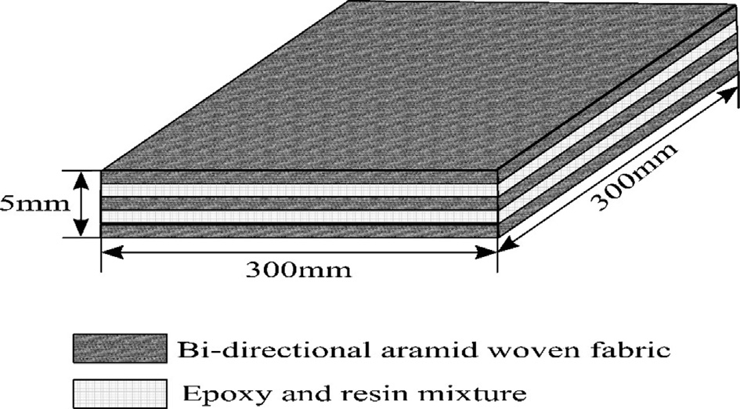

Fig. 1. Laminate layout.

Table 1. Properties of epoxy resin.

Property Unit Test method Value

Appearance - Visual Clear viscous liquid Color APHA ASTM D 1209 D 5386 Max. 100

Epoxy value Eq./kg ASTM D 1652 5.25e5.45 Viscosity at 25 ○C mPa-s ASTM D 2196 10000e12000 Hydrolysable chlorine % ASTM D 1726 Max. 0.1

Table 2. Properties of hardener.

Property Value

Appearance (Visual) Clear pale colored viscous liquid

Odor Amine

Color (Gardner, ASTM D 1544) 10 max

Viscosity at 40 ○C DIN 53015 (ISO 12058) 3000e6000 mPa-s

Density at 25 ○C (ASTM D 1457) 0.95e0.97 kg/l

Non-volatiles Solvent free

Amine numbers (ISO 9702) 370e400 mg KOH/g

Amine hydrogen equivalent wt. 95

Table 3. Properties of reinforcement.

“Customary” (inch-pound) units

Speciﬁc density lb/in3

Tenacity 103 psi

Modulus 106 psi

Break elongation

Speciﬁc tensile strength 106 in.

CTE 10L6/○F

Decomposition temperature (○F) (○C)

|  |  |  |  |  |  |  |  |
| --- | --- | --- | --- | --- | --- | --- | --- |
| 0.052 | 424 | 10.2 | 3.6 | 8.15 | —2.2 | 800e900 | (427e482) |
| 0.052 | 435 | 16.3 | 2.4 | 8.37 | —2.7 | 800e900 | (427e482) |

# Machining set-up

The machining setup used for drilling of AFRP is Triton VMC three-axis milling machine and is suitable for machining the wax, plastics, acrylics, copper, aluminum, composites, and steel as shown in Fig. 2. It has inbuilt PC controller, and solid car- bide drill bits of 6 mm, 8 mm, 10 mm diameter were used to perform the drilling trials. The speciﬁcation of solid carbide drill bit is shown in Fig. 3b and Table 4. Thrust force and torque developed during drilling operations were measured using KISTLER dynamometer as shown in Fig. 3a. Charge ampliﬁer produces a voltage output proportional to the force input, and the generated voltage is measured using Data Acquisition PC.

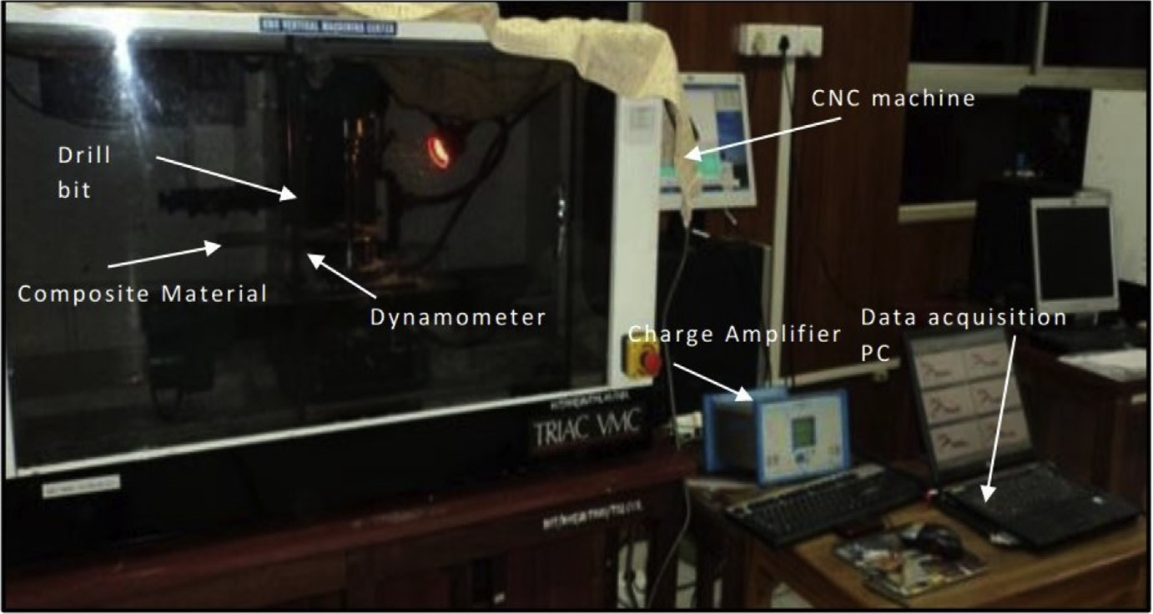

Fig. 2. Triton VMC (Vertical milling centre).

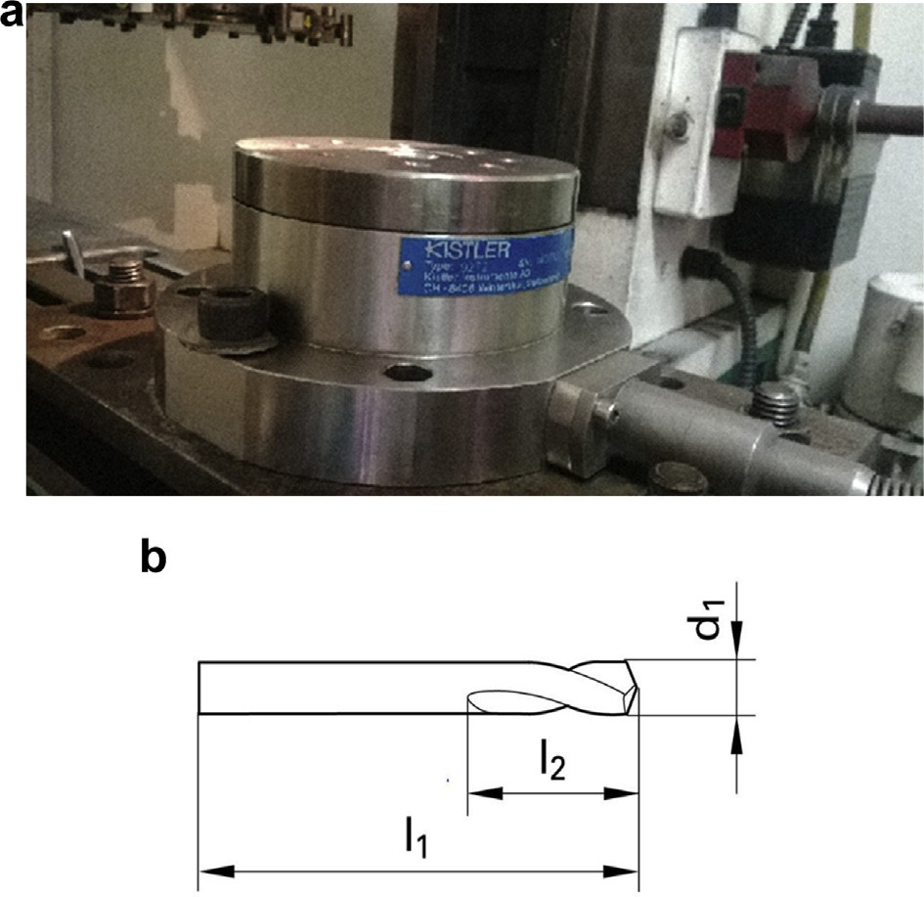

Fig. 3. (a) KISTLER dynamometer. (b) Solid carbide drill bit.

Table 4. Solid carbide drill bit speciﬁcations.

Drill point angle

Diameter Shank dia. OAL Flute length Cutting depth Flutes Shank Coating d1 d2 l1 l2 tMax

(mm) (mm) (mm) (mm) (mm)

90 degrees 6.000 6.000 66.00 16.00 7.00 2 Straight Bright

8.000 8.000 79.00 21.00 9.00 2 Straight Bright

10.000 10.000 89.00 25.00 10.00 2 Straight Bright

118 degrees 6.000 6.000 83.00 51.00 - Spiral - Bright

8.000 8.000 92.00 60.00 - Spiral - Bright

10.000 10.000 114.00 73.00 - Spiral -

Table 5. Factor information.

|  |  |  |  |
| --- | --- | --- | --- |
| Factor | Type | Level | Values |
| DA (Drill Point Angle) | Fixed | 2 | 90○, 118○. |
| DD (Drill Diameter) | Fixed | 3 | 6 mm, 8 mm, 10 mm. |
| SPEED (Spindle Speed) | Fixed | 3 | 600 rpm, 900 rpm, 1200 rpm. |
| FEED (Feed Rate) | Fixed | 3 | 50 mm/min, 75 mm/min, 100 mm/min. |
| 3. Methodology |  |  |  |
| 3.1. Taguchi method |  |  |  |

There are three types of Taguchi’s S-N ratio variations as given below. In the present work, *Smaller is better* was chosen as the variation.

|  |  |  |  |  |  |
| --- | --- | --- | --- | --- | --- |
| AFRP values were analyzed with the Taguchi method, and this method allows to | | | | | |
| perform a pair of combinations of tests. In this study, drill point angle, drill diameter, | | | | | |
| spindle speed and feed rate were selected. The drill parameters and levels are shown | | | | | |
| in Table 5. The experiments were conducted according to Taguchi’s | | | | L54 | Orthogonal |
| Array, shown in Table 6. The drill diameter, speed, and feed have three levels, and | | | | | |
| drill point angle had two levels. In this work, Taguchi’s L54 | | | (21*33) orthogonal array | | |
| was considered, as the L8 | (21*33) array was insuﬃcient to handle the data. In the cur- | | | | |
| rent study, ﬁfty-four sets of experiments were conducted using standard design ma- | | | | | |
| trix of factorial design. Drill parameters concerning thrust and torque forces were | | | | | |
| measured using S-N ratio. | |  | | | |

1. *Larger is better:* It is used when a more substantial value is desired as indicated in equation (1).

*S*=*N ratio*ðhÞ¼ —10 log

*n*

10*n*

1 X 1

*i*¼0

*y*

2

*i*

ð1Þ

where n is the number of replications and yi is observed response value.

1. *Nominal is the best:* It is used when variation about the nominal or target value is minimum as shown in equations (2) and (3).

*S*=*N ratio*

ðhÞ¼

m2

10 log10 s2 ð2Þ

*S*=*N ratio*ðhÞ¼ —10 log10s2 ð3Þ

where m is the mean and s is the variance.

1. *Smaller is better:* It is used when the smaller value is desired. The “*smaller is the better*” means minimizing the response and the target value is non-negative with zero [15].

Table 6. Taguchi’s L54 (21*33) orthogonal array.

|  |  |  |  |  |  |  |  |  |  |
| --- | --- | --- | --- | --- | --- | --- | --- | --- | --- |
| Test no. | DA | DD | SPEED | FEED | Test no. | DA | DD | SPEED | FEED |
| 1 | 90 | 6 | 600 | 50 | 28 | 118 | 6 | 600 | 50 |
| 2 | 90 | 6 | 600 | 75 | 29 | 118 | 6 | 600 | 75 |
| 3 | 90 | 6 | 600 | 100 | 30 | 118 | 6 | 600 | 100 |
| 4 | 90 | 6 | 900 | 50 | 31 | 118 | 6 | 900 | 50 |
| 5 | 90 | 6 | 900 | 75 | 32 | 118 | 6 | 900 | 75 |
| 6 | 90 | 6 | 900 | 100 | 33 | 118 | 6 | 900 | 100 |
| 7 | 90 | 6 | 1200 | 50 | 34 | 118 | 6 | 1200 | 50 |
| 8 | 90 | 6 | 1200 | 75 | 35 | 118 | 6 | 1200 | 75 |
| 9 | 90 | 6 | 1200 | 100 | 36 | 118 | 6 | 1200 | 100 |
| 10 | 90 | 8 | 600 | 50 | 37 | 118 | 8 | 600 | 50 |
| 11 | 90 | 8 | 600 | 75 | 38 | 118 | 8 | 600 | 75 |
| 12 | 90 | 8 | 600 | 100 | 39 | 118 | 8 | 600 | 100 |
| 13 | 90 | 8 | 900 | 50 | 40 | 118 | 8 | 900 | 50 |
| 14 | 90 | 8 | 900 | 75 | 41 | 118 | 8 | 900 | 75 |
| 15 | 90 | 8 | 900 | 100 | 42 | 118 | 8 | 900 | 100 |
| 16 | 90 | 8 | 1200 | 50 | 43 | 118 | 8 | 1200 | 50 |
| 17 | 90 | 8 | 1200 | 75 | 44 | 118 | 8 | 1200 | 75 |
| 18 | 90 | 8 | 1200 | 100 | 45 | 118 | 8 | 1200 | 100 |
| 19 | 90 | 10 | 600 | 50 | 46 | 118 | 10 | 600 | 50 |
| 20 | 90 | 10 | 600 | 75 | 47 | 118 | 10 | 600 | 75 |
| 21 | 90 | 10 | 600 | 100 | 48 | 118 | 10 | 600 | 100 |
| 22 | 90 | 10 | 900 | 50 | 49 | 118 | 10 | 900 | 50 |
| 23 | 90 | 10 | 900 | 75 | 50 | 118 | 10 | 900 | 75 |
| 24 | 90 | 10 | 900 | 100 | 51 | 118 | 10 | 900 | 100 |
| 25 | 90 | 10 | 1200 | 50 | 52 | 118 | 10 | 1200 | 50 |
| 26 | 90 | 10 | 1200 | 75 | 53 | 118 | 10 | 1200 | 75 |
| 27 | 90 | 10 | 1200 | 100 | 54 | 118 | 10 | 1200 | 100 |

*S*=*N ratio*ðhÞ¼ —10 log

*n*

10 *n*

1 X *y*2

*i*¼0

ð4Þ

# Analysis of variance (ANOVA)

*i*

ANalysis Of VAriance (ANOVA) is used to ﬁnd the signiﬁcance of each value in AFRP composites study. The variance seen in variables is partitioned into diﬀerent parts or components based on the deviation and hence the name ANalysis of VAri- ance (ANOVA). ANOVA compares diﬀerent factor levels with response to access the importance of one or more factors. General linear model (GLM) approach was

used in this experiment, and it uses least square regression method to describe the statistical relationship between one or more factors and the response variable. In this work, P-values were associated with Fischer’s F-test. The model is said to be adequate when F-ratio value is more than the standard tabulated F-ratio value at a conﬁdence interval of 95%.

# Response surface method (RSM)

In this work, Response Surface Method (RSM) was used to compute 3D surface and contour plots of AFRP drill parameter variations.

and mathematical procedures for ﬁguring out the relationship between the responses

to given problems and several factors aﬀecting the problem.

RSM is a collection of statistical

Proper planning of ex- periments was necessary to construct the mathematical model based on experimental data. For this reason, a second-degree non-linear polynomial regression was used to describe the relationship between drilling process parameters of AFRP and thrust and torque force, as shown in equation (5).

the regression line in algebraic format. In the current study, Central Composite

The chosen values before the experi- ment: number of cube points was 32; center points in the cube was 8; axial points was 10; center points in axial was 4 and the value of alpha for RSM was 2.366. The commercially available MINITAB software was used for the RSM study. By default, Minitab uses coded units to perform the RSM operation. Then these coded coeﬃcients were converted to un-coded coeﬃcients by Minitab software. Equation

Design (CCD) approach was used for RSM.

This equation is the representation of

(5) is the obtained regression equation in un-coded units.

*T*d ¼ b*o* þ b*1* DA þ b*2* DD þ b*3* SPEED þ b*4* FEED þ b*11* DA*DA þ b*22* DD*DD þ b*33* SPEED*SPEED þ b*44* FEED*FEED þ b*12* DA*DD þ b*13* DA* FEED þ b *14* DA*FEED þ b *23* DD*SPEED þ b *24* DD*FEED þ b *34* SPEED*FEED (5)

where, Td is the thrust or torque force, bo is the constant, b1.b44 is the regression co- eﬃcients of the model to be determined. DA, DD., SPEED*FEED are the values of the term.

# Modeling of genetic algorithm and neural network

The diversity of data can enhance the learning and generalization ability of neural network which can be obtained with a reduction in the similarity of data. Therefore, the data was normalized within the range [0, 1] for both input and output data using equation (6).

*x ymax* — *ymin*

¼

*n*

*xmax* — *xmin*

ð*x* — *x*

*min*

Þþ *y*

*min*

ð6Þ

where, xn is the normalized value of variable x; xmax and xmin are the maximum and minimum of x, respectively; ymax and ymin are the maximum and minimum of the normalized targets, respectively.

## *Multilayer perceptron neural network (MLPNN)*

This technique was used to predict the thrust and torque force in the drilling of AFRP composites. MLPNN consists of four neurons in the input layer corresponding to four input process parameters (SPEED: spindle speed, FEED: feed rate, DA: point angle and DD: drill diameter). The output layer consists of a single neuron which is either thrust force or torque force as output process parameters. A single hidden layer with Nh (number of hidden neurons) was used in this work as shown in Fig. 4. These also hold weights and biases in the hidden layer (Wij, bij) and an output layer (Wjk, bjk). Sigmoidal activation function was selected as activation function for both inputs and outputs. For training purpose, back-propagation (BP) algorithm was used in MLPNN. In this study, gradient descent with momentum and adaptive learning rate back propagation (gdx) was used due to its ability to update weights and biases. Also, other factors like learning rate (g) and momentum rate (m) were chosen as shown in Fig. 5. The Performance of MLPNN was validated through MSE (Mean Square Error) as given in equation (7). The learning rate parameter was used during the adjustment of weights and biases to control the speed of learning algorithm and activation functions (hyperbolic tangent sigmoid and log-sigmoid). Similarly, the momentum rate and number of hidden neurons also greatly aﬀect the outcome of MLPNN. In this work, MATLAB e NNTOOL was used to perform the neural network analysis. The selection process of number of data points for training, testing and validation will be carried out automatically in NNTOOL. How- ever, the factors like learning rate, epochs and time could be controlled in the study.

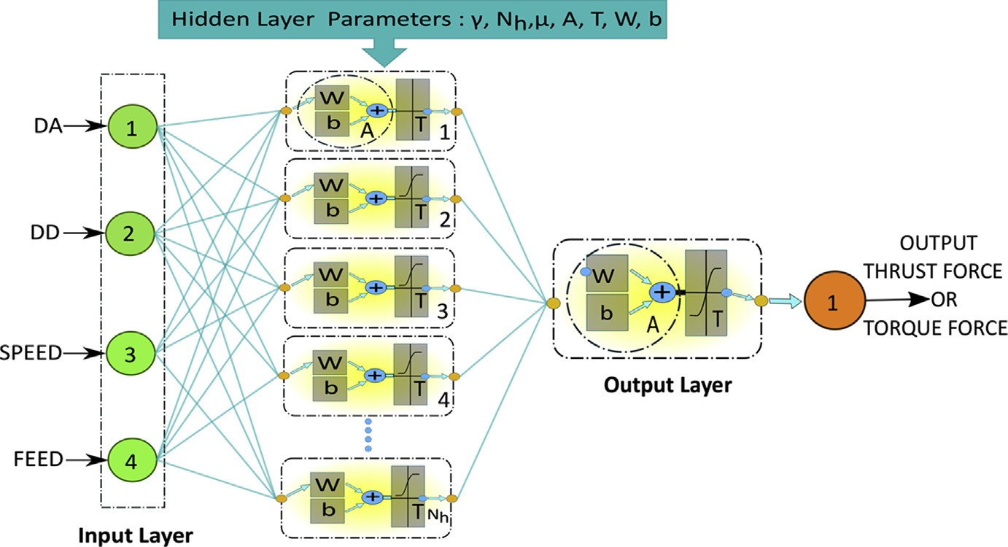

Fig. 4. Structure of MLPNN.

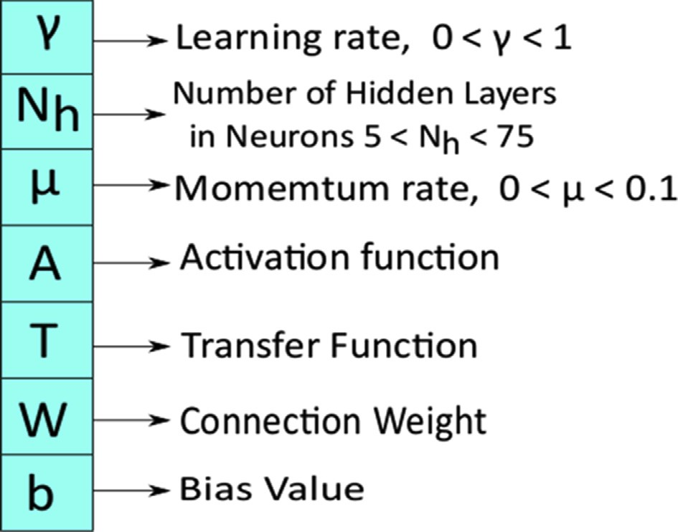

Fig. 5. MLPNN parameters.

*sum*ð*y* — *targets*Þ2

*MSE* ¼

*length*ð*y*Þ ð7Þ

where y is the net of input values and targets expected output value. The structure of MLPNN is shown in Fig. 4.

## *MLPNN optimized by genetic algorithm (MLPNN-GA)*

Conventional BP algorithm has a signiﬁcant drawback that it is to be trapped in local minima. Critical features of GA are global searching and evolution of parameters. Nat- ural selection theory and evolutionary biology (survival of the ﬁttest) theories were used to the global level solution. The global level solution passes through a selection of individuals, crossover, and mutation. Network training was used for evolution of MLPNN initial weights and biases. Exchange of weights and biases was used to communicate between GA and MLPNN. A random group of weights and biases [W,b] primarily initiated by MLPNN program is shown in Fig. 4 which forms the ﬁrst population for GA. The current population is generated based on an arbitrary number of generations. The ﬁtness function is the diﬀerence between the predicted output value and the actual output value. If the overall mean square error of GA is less than 0.005 only, then parameters are accepted. Equation (8) was used to calculate weights and bias.

Nw ¼ (Inþ1) * Nhþ (Nhþ1) * Op (8)

where Nw is an array of weight and bias, In is the number of neurons in input layer, Nh is the number of neurons in hidden layer and Op is the number of neurons in output layer.

For the GA operation population size of 20, and mutation and crossover, the rate of

0.2 and 0.6 were selected. This optimum weight and bias were embedded into 4-5-1 existing MLPNN as new weight and bias. Optimum values of thrust and torque

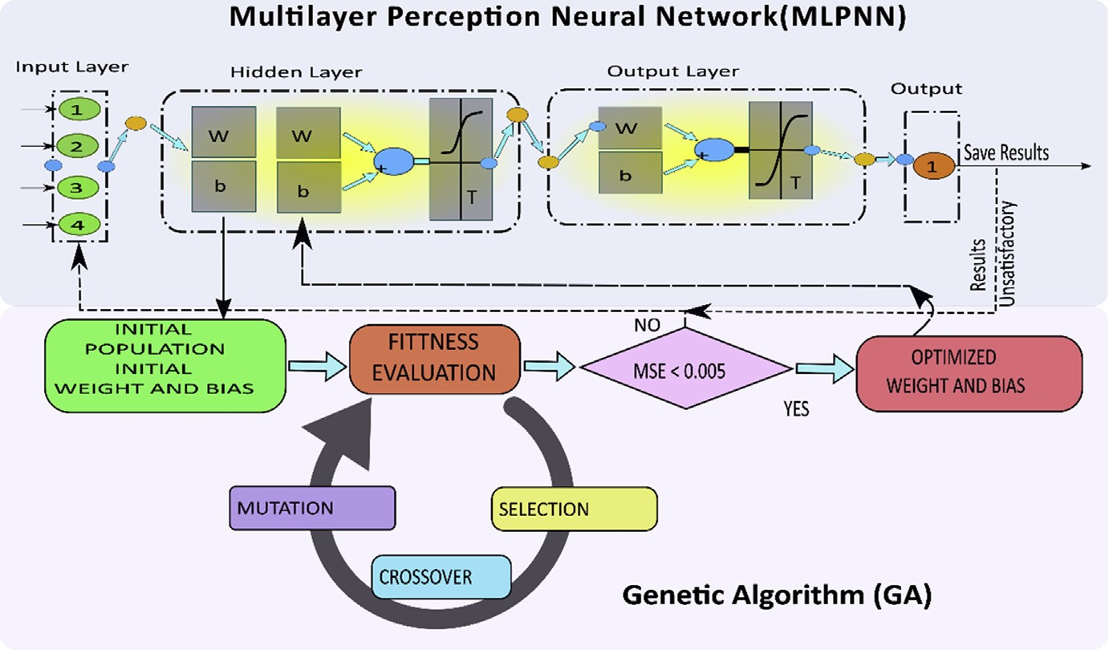

Fig. 6. Structure of MLPNN-GA.

values were chosen by training the MLPNN network. MLPNN-GA process is shown in Fig. 6 and optimization ﬂowchart is shown in Fig. 7.

# Response optimizer (RO)

Response optimizer is one of the tools of RSM. In this work, RO was used to ﬁnd the optimum parameters for the thrust and torque force. It is an advanced tool to opti- mize the set of response variables by a combination of input variables. It quantiﬁes the relationship between the controllable input parameters and the obtained response surfaces. It calculates the optimal solution, produces an optimization plot and per- forms the sensitivity analysis.

# Results and discussion

This section is divided into four subsections: (1) Hypothesis, (2) Analysis of RSM,

MLPNN-GA, and ANOVA predictive mode, (3) Eﬀect of process parameters on

thrust and torque force, and (4) Selection of optimum parameters.

* 1. Hypothesis

The following assumptions were made for analyzing the thrust and torque models:

* The loading of the tool is uniformly distributed and not present at the centre of tool;
* The laminate does not bend during drilling under the thrust or torque generated by the tool; and
* Peel up delamination was considered negligible as compared to push out delamination.

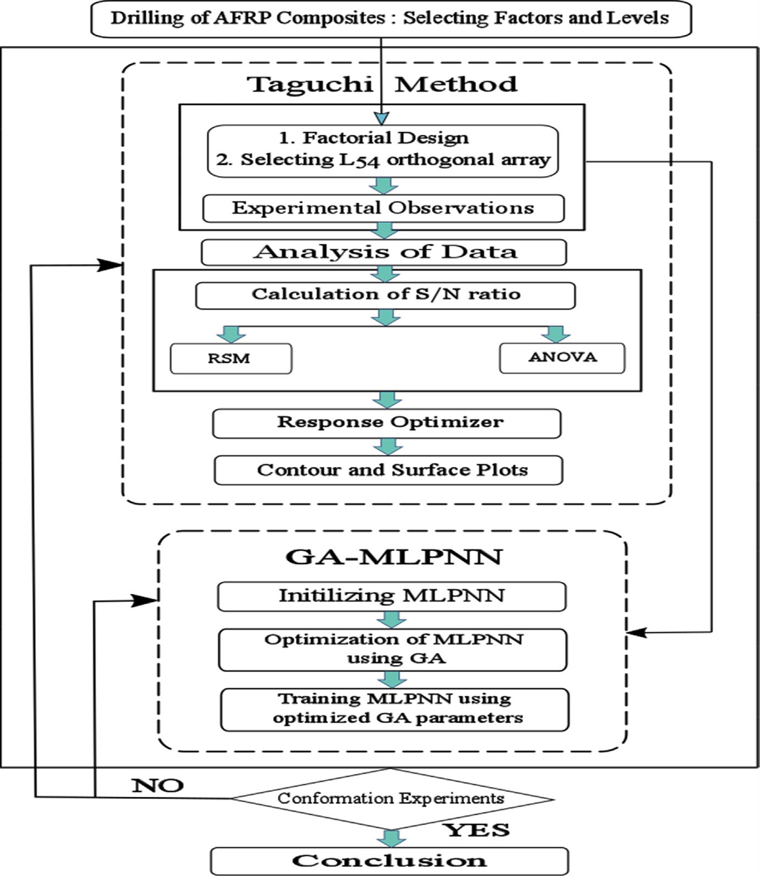

Fig. 7. Flowchart for optimization.

# Thrust force

The thrust force was measured experimentally and predicted by RSM and MLPNN- GA during the drilling of AFRP composites, as shown in Table 7. In this study, solid carbide drill bit was used.

## *Analysis of predictive models*

* + - 1. *Analysis of ANOVA*

|  |  |  |  |  |
| --- | --- | --- | --- | --- |
| The goodness of the ﬁt ANOVA had been performed and the results of ANOVA are | | | | |
| shown in Table 8. The P-values less than 0.05 indicated that the model was quite | | | | |
| adequate at 95% conﬁdence limit. In addition, the goodness of the ﬁt had been tested | | | | |
| by the correlation coeﬃcient, | R2. | The predicted | R2 | value of 97.93% is in good |

https://doi.org/10.1016/j.heliyon.2018.e00703

2405-8440/© 2018 The Authors. Published by Elsevier Ltd. This is an open access article under the CC BY-NC-ND license ([http://creativecommons.org/licenses/by-nc-nd/4.0/).](http://creativecommons.org/licenses/by-nc-nd/4.0/))

Table 7. Experimental and predicted results of thrust force during drilling of AFRP composites.

16

|  |  |  |  |  |  |  |  |  |  |
| --- | --- | --- | --- | --- | --- | --- | --- | --- | --- |
| Test no. | THRUST |  |  |  | Test no. | THRUST |  | | |
|  | aExp. | RSM | bMLPNN | cMLPNN-GA |  | aExp. | RSM | bMLPNN | cMLPNN-GA |
| 1 | 98.32 | 98.928 | 97.243 | 100.923 | 28 | 122.31 | 123.919 | 123.134 | 123.684 |
| 2 | 100.61 | 100.957 | 101.342 | 99.266 | 29 | 126.76 | 126.465 | 124.327 | 127.138 |
| 3 | 101.45 | 102.027 | 103.221 | 101.022 | 30 | 129.44 | 128.052 | 130.579 | 129.421 |
| 4 | 87.59 | 88.097 | 88.812 | 87.398 | 31 | 120.04 | 113.186 | 118.254 | 119.791 |
| 5 | 91.75 | 91.387 | 91.403 | 90.839 | 32 | 113.78 | 116.993 | 115.610 | 113.003 |
| 6 | 94.49 | 93.717 | 92.720 | 95.676 | 33 | 118.49 | 119.840 | 119.090 | 118.881 |
| 7 | 74.68 | 77.716 | 75.322 | 73.542 | 34 | 102.06 | 102.903 | 103.902 | 102.767 |
| 8 | 86.03 | 82.267 | 87.625 | 87.355 | 35 | 104.72 | 107.971 | 106.192 | 103.059 |
| 9 | 86.77 | 85.858 | 86.420 | 85.635 | 36 | 113.07 | 112.079 | 111.119 | 113.280 |
| 10 | 112.44 | 111.498 | 110.532 | 110.238 | 37 | 137.37 | 137.617 | 138.193 | 138.358 |
| 11 | 114.43 | 112.412 | 113.309 | 113.022 | 38 | 137.72 | 139.048 | 136.763 | 138.132 |
| 12 | 111.52 | 112.366 | 110.238 | 112.079 | 39 | 138.87 | 139.519 | 138.391 | 137.206 |
| 13 | 98.57 | 100.590 | 99.601 | 99.841 | 40 | 128.59 | 126.807 | 127.924 | 127.773 |
| 14 | 102.92 | 102.765 | 103.758 | 101.261 | 41 | 130.06 | 129.499 | 131.014 | 129.658 |
| 15 | 102.40 | 103.980 | 101.005 | 103.813 | 42 | 132.54 | 131.230 | 130.605 | 133.815 |
| 16 | 91.84 | 90.132 | 92.142 | 91.104 | 43 | 114.84 | 116.447 | 113.065 | 114.945 |
| 17 | 93.50 | 93.568 | 93.351 | 91.738 | 44 | 121.71 | 120.399 | 123.520 | 119.578 |

(*continued on next page*)

*Article No*w*e00703*

https://doi.org/10.1016/j.heliyon.2018.e00703

2405-8440/© 2018 The Authors. Published by Elsevier Ltd. This is an open access article under the CC BY-NC-ND license ([http://creativecommons.org/licenses/by-nc-nd/4.0/).](http://creativecommons.org/licenses/by-nc-nd/4.0/))

Table 7. (*Continued* )

17

|  |  |  |  |  |  |  |  |  |  |
| --- | --- | --- | --- | --- | --- | --- | --- | --- | --- |
| Test no. | THRUST |  |  |  | Test no. | THRUST |  |  |  |
|  | aExp. | RSM | bMLPNN | cMLPNN-GA |  | aExp. | RSM | bMLPNN | cMLPNN-GA |
| 18 | 94.26 | 96.043 | 94.461 | 95.735 | 45 | 123.73 | 123.392 | 124.220 | 124.637 |
| 19 | 107.55 | 108.265 | 108.091 | 108.971 | 46 | 134.29 | 135.512 | 132.781 | 135.257 |
| 20 | 108.32 | 108.064 | 106.635 | 108.270 | 47 | 135.65 | 135.827 | 134.133 | 135.376 |
| 21 | 109.03 | 106.902 | 107.503 | 110.901 | 48 | 136.48 | 135.183 | 134.187 | 136.417 |
| 22 | 98.45 | 97.280 | 100.034 | 98.967 | 49 | 125.43 | 124.624 | 126.897 | 125.127 |
| 23 | 96.28 | 98.339 | 97.320 | 96.315 | 50 | 126.62 | 126.201 | 127.011 | 126.337 |
| 24 | 97.64 | 98.439 | 98.912 | 98.944 | 51 | 124.15 | 126.817 | 125.773 | 124.389 |
| 25 | 87.94 | 86.745 | 88.154 | 87.903 | 52 | 112.14 | 114.187 | 113.264 | 113.290 |
| 26 | 88.72 | 89.065 | 89.987 | 88.188 | 53 | 118.67 | 117.024 | 117.442 | 119.439 |
| 27 | 90.33 | 90.425 | 91.468 | 90.443 | 54 | 120.11 | 118.901 | 123.001 | 121.024 |
|  |  |  |  |  | Error (Avg.) |  | 1.23% | 1.100% | 0.83% |

a Experimental.

b Average values for 54 trials of MLPNN-initial weights and bias.

c Average values for 54 trials of MLPNN after optimizing the initial weights and bias using MLPNN-GA model.

*Article No*w*e00703*

Table 8. Analysis of Variance (ANOVA) for thrust force.

Source DF Seq SS Adj SS Adj MS F-value P-value % Contribution

|  |  |  |  |  |  |  |  |
| --- | --- | --- | --- | --- | --- | --- | --- |
| Model | 13 | 14370.9 | 14370.9 | 1105.45 | 268.53 | 0.000 | 98.87% |
| *Linear* | 4 | 13536.2 | 13536.2 | 3384.05 | 822.04 | 0.000 | 93.12% |
| DA | 1 | 9648.3 | 9648.3 | 9648.33 | 2343.73 | 0.000 | 66.38% |
| DD | 1 | 587.6 | 587.6 | 587.58 | 142.73 | 0.000 | 4.04% |
| SPEED | 1 | 3162.9 | 3162.9 | 3162.94 | 768.33 | 0.000 | 21.76% |
| FEED | 1 | 137.4 | 137.4 | 137.36 | 33.37 | 0.000 | 0.94% |
| *Square* | 3 | 752.6 | 752.6 | 250.87 | 60.94 | 0.000 | 5.18% |
| DD*DD | 1 | 749.2 | 749.2 | 749.24 | 182.00 | 0.000 | 5.15% |
| SPEED*SPEED | 1 | 0.6 | 0.6 | 0.61 | 0.15 | 0.703 | 0.00% |
| FEED*FEED | 1 | 2.8 | 2.8 | 2.76 | 0.67 | 0.417 | 0.02% |
| *2-Way interaction* | 6 | 82.1 | 82.1 | 13.68 | 3.32 | 0.009 | 0.56% |
| DA*DD | 1 | 11.4 | 11.4 | 11.45 | 2.78 | 0.103 | 0.08% |
| DA*SPEED | 1 | 0.1 | 0.1 | 0.09 | 0.02 | 0.886 | 0.00% |
| DA*FEED | 1 | 2.4 | 2.4 | 2.40 | 0.58 | 0.449 | 0.02% |
| DD*SPEED | 1 | 0.1 | 0.1 | 0.14 | 0.03 | 0.853 | 0.00% |
| DD*FEED | 1 | 29.9 | 29.9 | 29.86 | 7.25 | 0.010 | 0.21% |
| SPEED*FEED | 1 | 38.2 | 38.2 | 38.15 | 9.27 | 0.004 | 0.26% |
| Error | 40 | 164.7 | 164.7 | 4.12 |  |  | 1.13% |
| Total | 53 | 14535.6 |  |  |  |  | 100.00% |
| Model summary of ANOVA | | | S 2.02896 | *R-sq*  98.87% | *R-sq(adj)*  98.50% | *R-sq(pred)*  97.93% | |

*R-sq* R2; Percentage variation with respect to the response. Higher the R2 value, better is the model

¼

ﬁtness.

*R-sq(adj)* adjusted R2; Percentage variation with respect to the response. Value is adjusted relative to number of predictors and observations in the model. It helps in choosing the correct model by number of predictors.

¼

*R-sq(pred)* ¼ predicted R2; It determines how well the model predicts when observation is removed.

However, DA and speed were the most signiﬁcant factors aﬀecting the thrust force. Moreover, residual analysis was performed to check the accuracy of the model. The normal probability plot of the residuals of thrust force is shown in Figs. 8 and 9 illustrates that the errors were normally distributed and follow a straight line which supported the least square ﬁt. The value of R2 is found to be 98.87% indicating an excellent goodness of the ﬁt and clariﬁed that excellent varia- tion in the output between response and targets.

|  |  |  |  |
| --- | --- | --- | --- |
| agreement with an adjusted | | R2 | value of 98.50%. So, it conﬁrmed that the model |
| could be accepted; and the values DA, DD, speed, and feed were directly related | | | |
| to thrust force. |  | | |

Equation (9) describes the calculated thrust force from regression coeﬃcients of Equation (5).

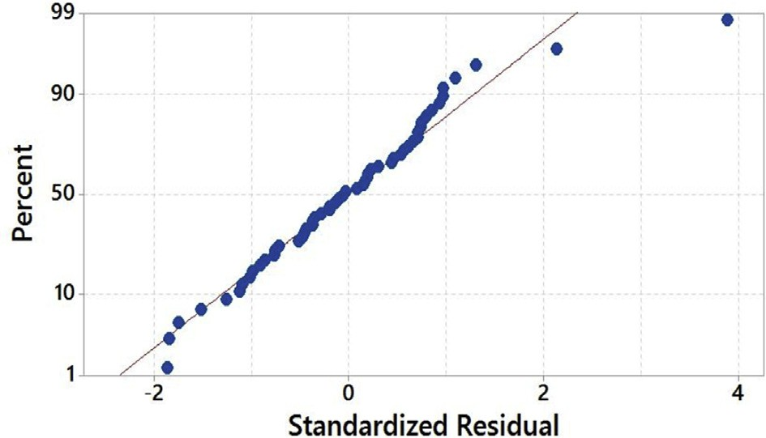

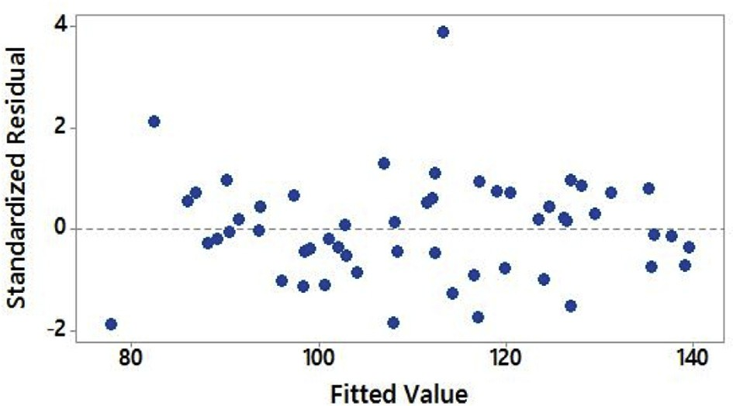Fig. 8. Normal probability plot of residuals.

Fig. 9. Plot of residuals against ﬁtted values.

THRUST ¼ —85.1 þ 0.728 DA þ 33.32 DD — 0.0485 SPEED þ 0.144 FEED —

1.975 DD*DD þ 0.000002 SPEED*SPEED — 0.000768 FEED*FEED þ 0.0201

DA*DD þ 0.000012 DA*SPEED þ 0.000738 DA*FEED — 0.000128

DD*SPEED — 0.02231 DD*FEED þ 0.000168 SPEED*FEED (9)

## *Analysis of MLPNN-GA*

Fig. 10 shows linear regression between training, validation, and testing of MLPNN- GA model after optimizing the initial weight and bias of MLPNN model. From Fig. 10, it is conﬁrmed that target line ratio of MLPNN-GA model oscillated slightly demonstrating that the predicted value diﬀered from experimentally measured value. Moreover, the predicted values were nearer to one which signiﬁed that there is an excellent linear relationship between the output value and experimentally deter- mined value. The optimal MLPNN-GA conﬁguration obtained is 4-5-1 (ﬁve neurons in Nh) with learning rate and momentum rate values of 0.7534 and 0.0025 respec- tively. Final values of MLPNN training record are shown in Table 9.

## *Comparison of RSM, MLPNN and MLPNN-GA models*

Table 7 and Fig. 11 exhibited the values and plots of experimentally measured thrust force and predicted from RSM, MLPNN, and MLPNN-GA. From Table 7 and

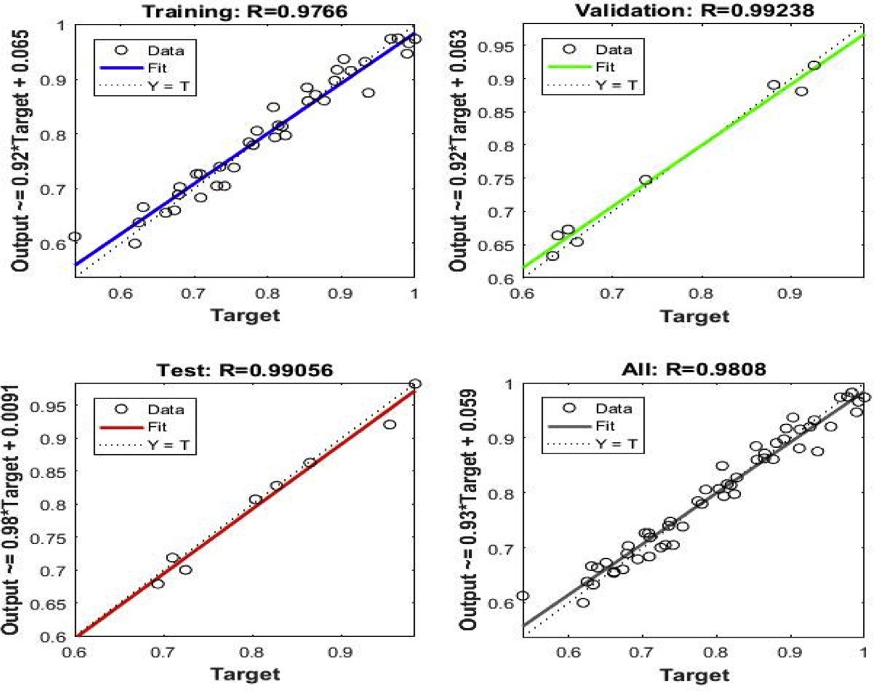

Fig. 10. Linear regressions of predictions and targets of MLPNN-GA thrust force.

Fig. 11, it is observed that MLPNN-GA model exhibited lower variations than the MLPNN model and MLPNN model was bound to local minima [37]. From Fig. 11, it is conﬁrmed that RSM and MLPNN-GA predicted values were closely related to experimentally measured thrust force. Before optimization of initial weights and bias, an average error of 1.1% was noticed with MLPNN. However, when weights and biases were optimized using MLPNN-GA model, the average er- ror was reduced to 0.83% and the number of times required to train MLPNN-GA also reduced. The study showed that MLPNN-GA has less average error than that of RSM. Though, RSM and MLPNN-GA models achieved an average error of less than 4%, and both the models could be used for predicting thrust force during drilling of AFRP composites. From the Table 7, we can realize that average error of RSM was greater than MLPNN and GA-MLPNN techniques. The reason could be due to RSM is a straightforward approach and there no place for tuning the values. On the other hand, in MLPNN-GA the ﬁne-tuning of the weight and bias of MLPNN could be done; and new weight and bias can be re-uploaded to the existing neural network to get the ﬁnal accurate and precision values. From Fig. 10 its conﬁrmed that MLPNN-GA model has superior performance and computation time taken by MLPNN-GA was 20 times more than that of RSM.

## *Eﬀect of process parameters on thrust force*

Thrust force in the drilling of AFRP composites had been analyzed through RSM by generating 3D response surface plots and counterplots. Fig. 12a and b exhibits the

Table 9. MLPNN training record for thrust force.

Parameter Value

trainFcn ‘traingdx’

trainParam [1 × 1 nnetParam]

performFcn ‘mse’

performParam [1 × 1 struct]

derivFcn ‘defaultderiv’

divideFcn ‘dividerand’

divideMode ‘sample’

divideParam [1 × 1 struct]

trainInd [1 × 38 double]

valInd [2 3 12 18 33 36 44 53]

testInd [11 13 27 29 31 41 43 48]

stop ‘Maximum epoch reached.’

num_epochs 5000

trainMask {[1 × 54 double]}

valMask {[1 × 54 double]}

testMask {[1 × 54 double]}

best_epoch 18

goal 0

states {‘epoch’ ‘time’ ‘perf’ ‘vperf’ ‘tperf’ ‘gradient’ ‘val_fail’ ‘lr’}

epoch [1 × 5001 double]

time [1 × 5001 double]

perf [1 × 5001 double]

vperf [1 × 5001 double]

tperf [1 × 5001 double]

gradient [1 × 5001 double]

val_fail [1 × 5001 double]

lr [1 × 5001 double]

best_perf 5.5930

best_vperf 0.3192

best_tperf 4.0740

inﬂuence of drill point angle and drill diameter on thrust force when speed and feed was held constant at 1200 rpm and 50 mm/min respectively. Fig. 13a and b exhibits the eﬀect of drill point angle and drill diameter on thrust force when speed and feed was held constant at 600 rpm and 100 mm/min respectively. From Figs. 12a and 13a, observed that drill point angle and drill diameter were sensitive to thrust force and non-linear to the given speed and feed. Similarly, at higher speed and lower feed the induced thrust force was less than that of the lower speed and higher feed, see Figs. 12b and 13b. The study showed that irrespective of the drill point angle and

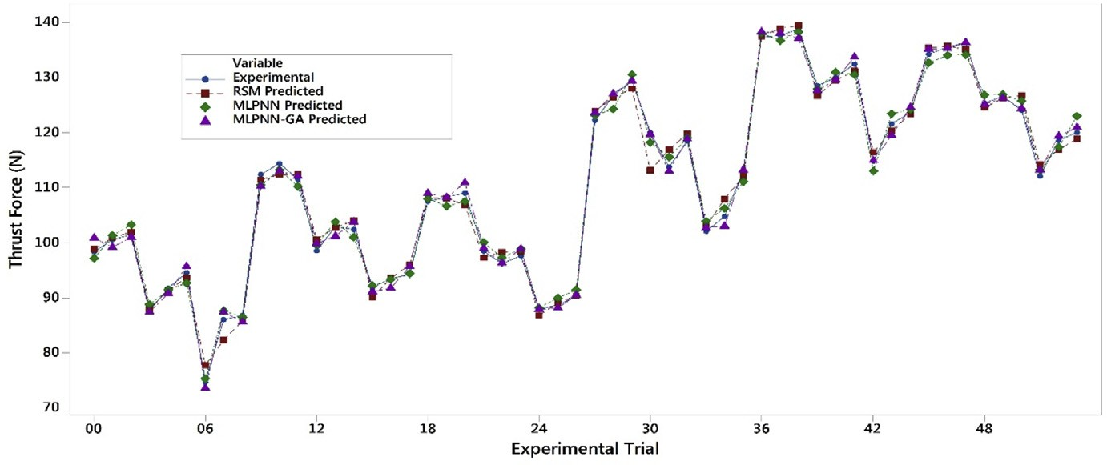

Fig. 11. Comparison of experiment and predicted results for thrust force.

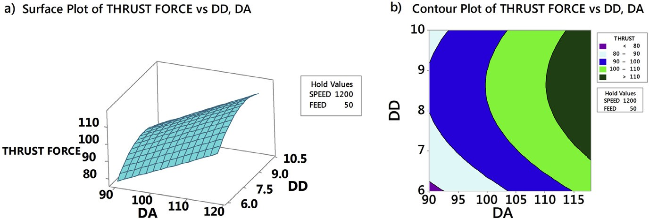

Fig. 12. Eﬀect of drill point angle and drill diameter on thrust force for a speed ¼ 1200 rpm and feed ¼

50 mm/min.

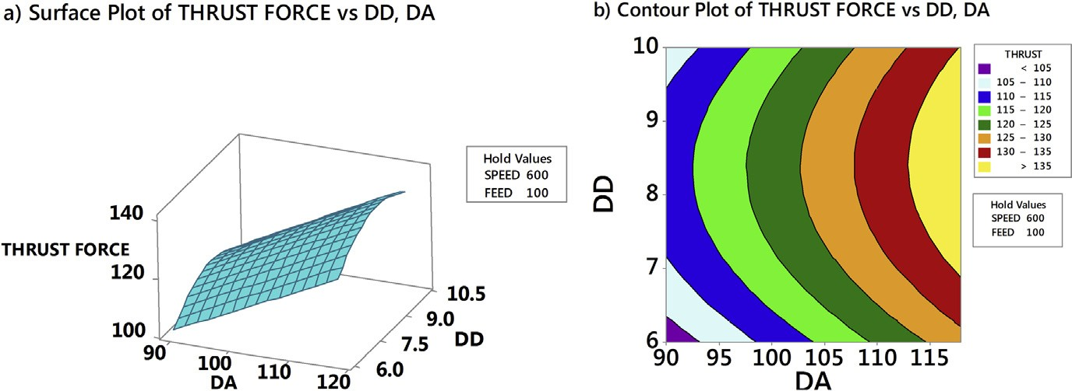

Fig. 13. Eﬀect of drill point angle and drill diameter on thrust force for a speed ¼ 600 rpm and feed ¼

100 mm/min.

drill diameter, higher speed and lower feed was necessary to obtain less thrust force; which justiﬁed the importance of high-speed in drilling [10, 15]. Fig. 14a and b ex- hibited the interaction of SPEED and FEED on thrust force when drill point angle and drill diameter held constant at 90○ and 6 mm respectively. Similarly, interaction due to SPEED and FEED on thrust force, when drill point angle and feed was held constant at 118○ and 10 mm respectively is highlighted in Fig. 15a and b. From Figs. 14a and 15a conﬁrmed that speed and feed vary linearly with the chosen drill point angle and drill diameter; and from Figs. 14b and 15b observed that maintaining

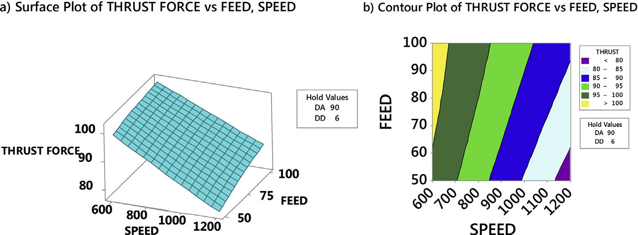

Fig. 14. Eﬀect of speed and feed on thrust force for a point angle ¼ 90○ and drill diameter ¼ 6 mm.

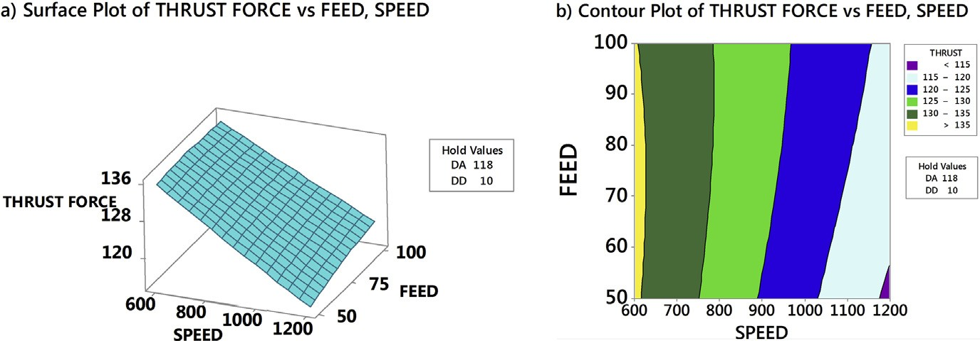

Fig. 15. Eﬀect of speed and feed on thrust force for a point angle ¼ 118○ and drill diameter ¼ 10 mm.

lower drill point angle and drill diameter resulted in less thrust force. Thus, overall study results indicated that minimum thrust force resulted from the combination of lower values of drill point angle, drill diameter, feed, and higher amounts of speed. Also, from response surface analysis, it is conﬁrmed that low values of drill point angle and drill diameter is advantageous in the drilling of AFRP composites to reduce the damage. However, rise in cutting speed resulted in temperature increase due to friction between the board and the cutting edge, which led to softening of the matrix. This resulted in decrease of cut ﬁbres and less deformed matrix, hence lower damage to the surface. When the drill point angle is reduced, the cross-sectional area of un-deformed chip decreased which resulted in cutting edge angle reduction. Hence, the thrust force is reduced as shown in Figs. 16 and 17. Moreover when the drill diameter was increased, the contact area of the hole also augmented which resulted in increased thrust force. Similarly, the feed rate is in direct relationship with the area of cut; as the feed increased the area of cut increased which demanded more thrust force and caused damage to the workpiece.

## *Selection of optimum parameters*

The obtained thrust force results were transformed into S-N ratio using Equation (9). Table 10 and Fig. 18 represent response table for S-N ratio and plot of S-N ratio respectively. Delta values measure the size of the eﬀect by taking the diﬀerence

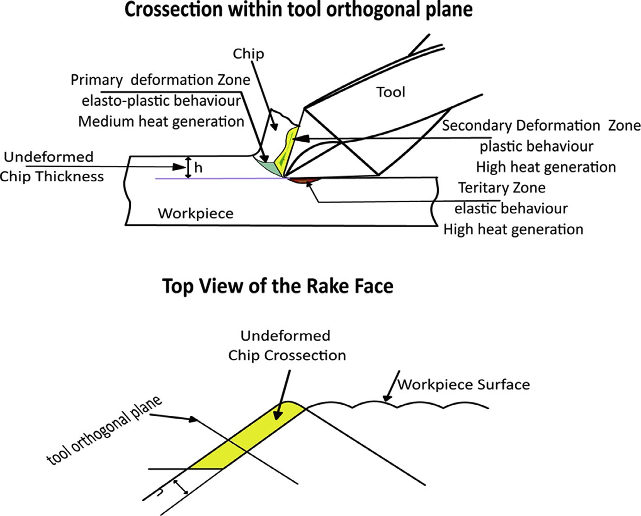

Fig. 16. Drill point angle 90○.

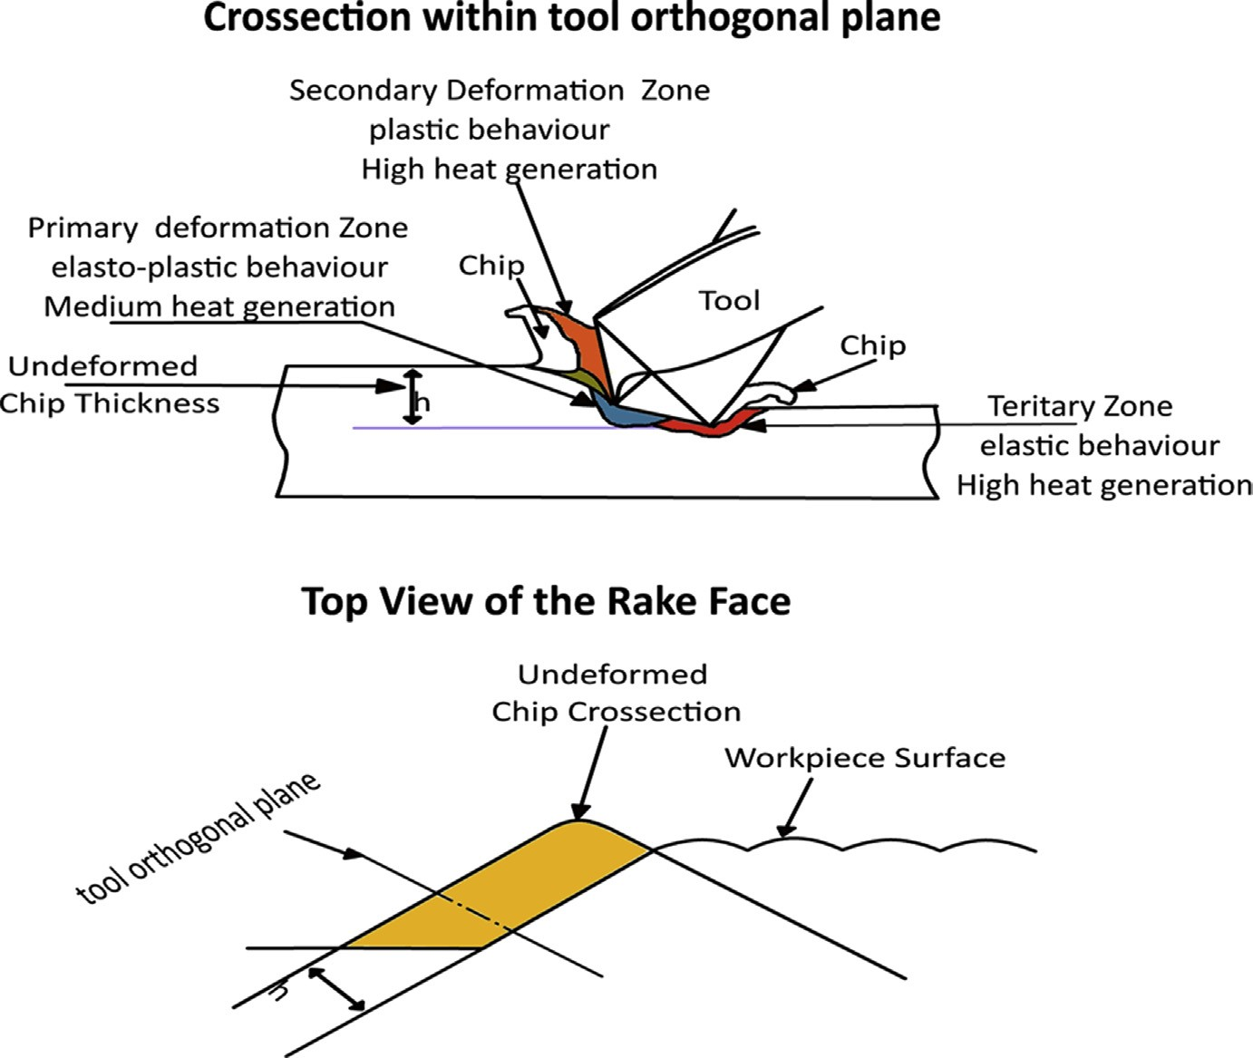

Fig. 17. Drill point angle 118○.

Table 10. Response table for signal to noise ratios.

Level DA DD SPEED FEED

|  |  |  |  |  |
| --- | --- | --- | --- | --- |
| 1 | —39.72 | —40.25 | —41.53 | —40.60 |
| 2 | —41.85 | —41.21 | —40.79 | —40.82 |
| 3 |  | —40.90 | —40.03 | —40.93 |
| Delta | 2.12 | 0.96 | 1.50 | 0.33 |
| Rank | 1 | 3 | 2 | 4 |

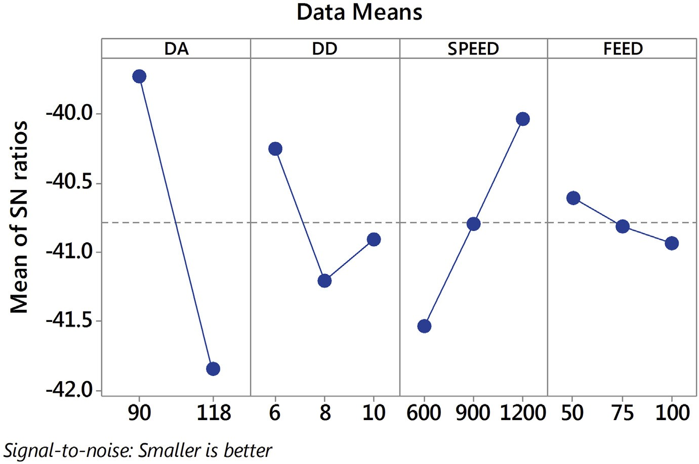

Fig. 18. Thrust force: plot of S-N ratio.

between the highest and least characteristic average for a factor. From Table 10 and Fig. 18, it is conﬁrmed that drill point angle is the most signiﬁcant factor aﬀecting the thrust force followed by spindle speed, drill diameter and feed.

## *Optimization of thrust force*

RSM and MLPNN-GA were used to optimize the torque force. From Figs. 19 and 20 conﬁrmed that optimal values of thrust force were close to each other with a devia- tion of less than 1% error. Thus, from the study it is conﬁrmed that both RSM and MLPNN-GA could be used for modeling the thrust force. According to Figs. 19 and 20 the DA value of 90○, DD of 6 mm, the speed of 1200 rpm and feed of 50 mm/min is the best combination to obtain the minimum thrust force.

# Torque

Table 11 represents the experimentally measured toque force using solid carbide drill bit and predicted from RSM and MLPNN-GA.

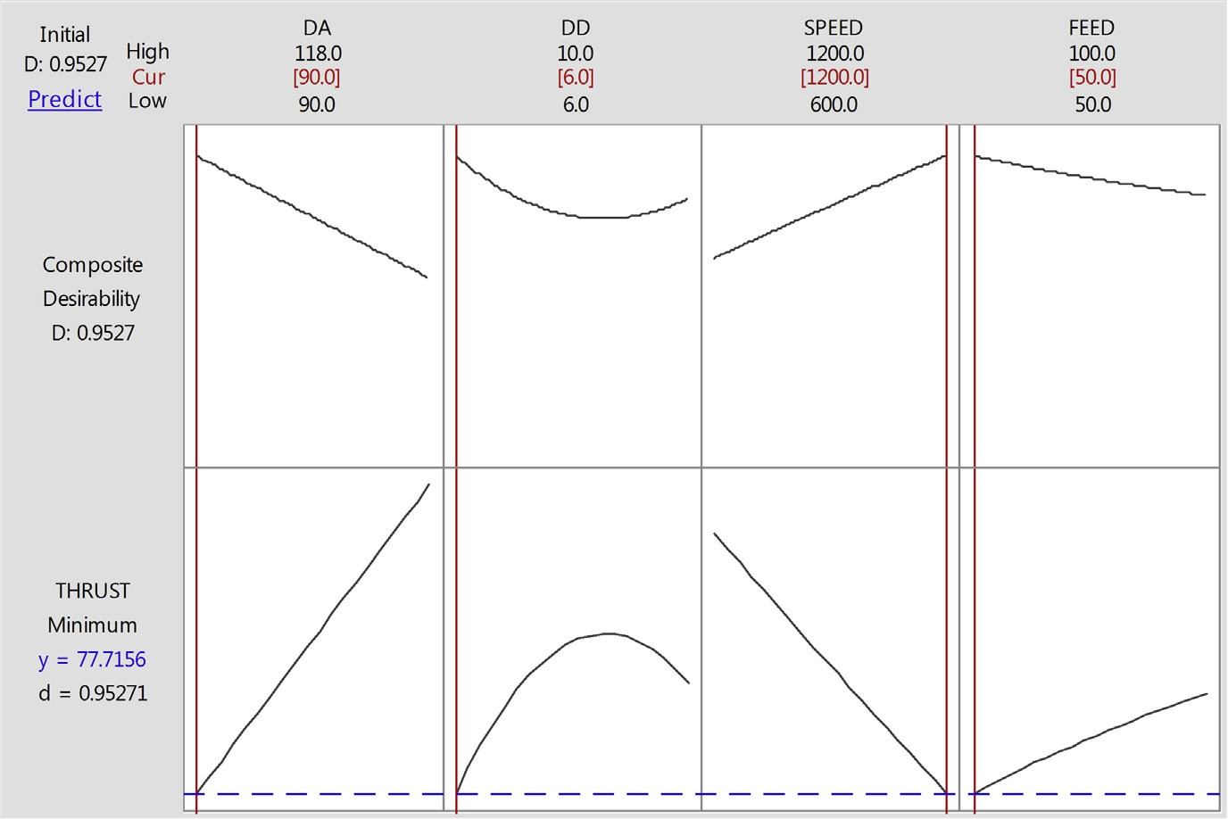

Fig. 19. RSM: optimization plot of thrust force.

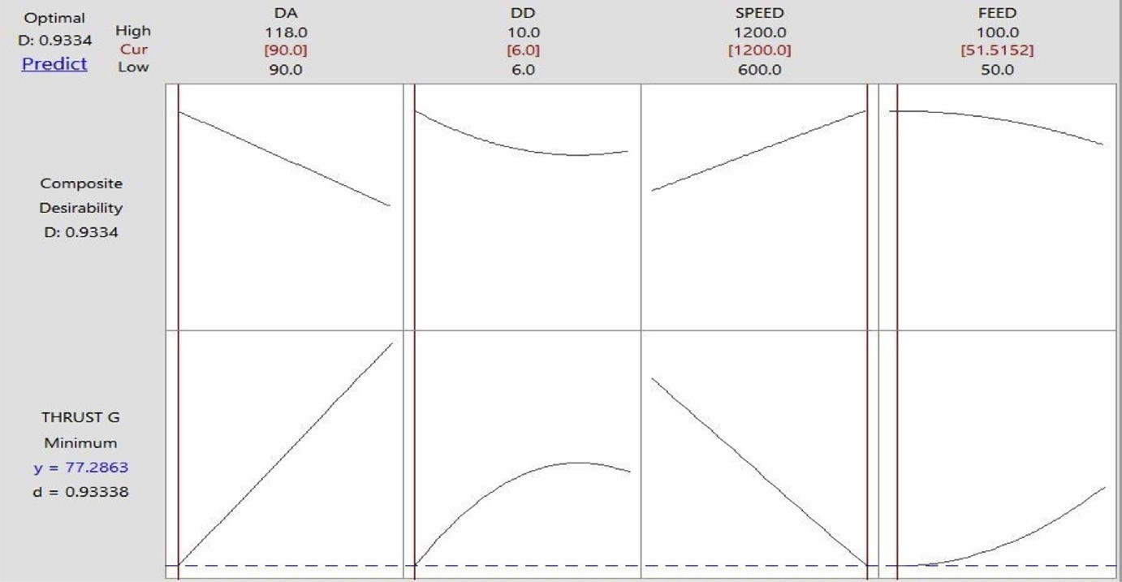

Fig. 20. MLPNN-GA: optimization plot of thrust force.

## *Analysis of RSM, MLPNN-GA and ANOVA predictive* models

* + - 1. *Analysis of RSM*

The goodness of the ﬁt ANOVA had been performed, and the results of ANOVA are shown in Table 12. The P-values less than 0.05 indicated that the model is quite adequate at 95% conﬁdence limit. Further, the goodness of the ﬁt had been tested by the correlation coeﬃcient, R2. The predicted R2 value of 91.33% is in good agree- ment with adjusted R2 value of 93.57% and conﬁrmed that the model could be accepted. The studies proved that DA and speed were the most signiﬁcant factors

Table 11. Experimental and predicted results of torque force during drilling of AFRP composite.

Test no.

|  |  |  |  |  |  |  |  |  |  |
| --- | --- | --- | --- | --- | --- | --- | --- | --- | --- |
|  | Exp. | RSM | MLPNN | MLPNN-GA |  | Exp. | RSM | MLPNN | MLPNN-GA |
| 1 | 20.82 | 19.989 | 20.664 | 20.141 | 28 | 18.33 | 17.983 | 17.297 | 18.038 |
| 2 | 20.64 | 20.114 | 20.331 | 19.691 | 29 | 16.66 | 18.039 | 16.277 | 17.133 |
| 3 | 20.24 | 19.488 | 20.229 | 20.905 | 30 | 16.16 | 17.344 | 16.007 | 16.392 |
| 4 | 17.41 | 18.295 | 17.013 | 17.429 | 31 | 17.02 | 17.161 | 17.061 | 17.040 |
| 5 | 18.20 | 18.701 | 18.321 | 19.126 | 32 | 17.80 | 17.498 | 16.566 | 17.408 |
| 6 | 18.03 | 18.354 | 18.961 | 18.643 | 33 | 17.83 | 17.082 | 17.340 | 18.046 |
| 7 | 15.99 | 15.805 | 15.397 | 15.570 | 34 | 15.59 | 15.542 | 15.912 | 16.010 |
| 8 | 16.79 | 16.490 | 16.219 | 16.993 | 35 | 16.51 | 16.159 | 16.022 | 16.605 |
| 9 | 16.91 | 16.424 | 16.187 | 17.086 | 36 | 15.57 | 16.023 | 16.211 | 15.570 |
| 10 | 22.09 | 20.005 | 23.129 | 21.907 | 37 | 17.30 | 17.644 | 17.757 | 17.047 |
| 11 | 20.01 | 20.282 | 20.315 | 20.239 | 38 | 17.75 | 17.852 | 18.882 | 17.628 |
| 12 | 20.33 | 19.807 | 21.091 | 20.079 | 39 | 18.22 | 17.309 | 19.008 | 17.884 |
| 13 | 16.19 | 18.685 | 16.802 | 15.679 | 40 | 18.02 | 17.197 | 18.305 | 17.047 |
| 14 | 17.55 | 19.243 | 17.493 | 17.869 | 41 | 17.90 | 17.685 | 18.533 | 17.964 |
| 15 | 18.39 | 19.048 | 19.331 | 19.133 | 42 | 17.68 | 17.421 | 16.723 | 18.113 |
| 16 | 16.56 | 16.569 | 17.222 | 16.584 | 43 | 16.19 | 15.952 | 16.099 | 17.048 |
| 17 | 17.41 | 17.406 | 16.129 | 17.708 | 44 | 17.26 | 16.720 | 17.434 | 17.219 |
| 18 | 17.28 | 17.491 | 17.595 | 17.899 | 45 | 16.93 | 16.736 | 17.883 | 16.500 |
| 19 | 25.39 | 26.578 | 25.934 | 25.853 | 46 | 23.62 | 23.863 | 23.447 | 23.752 |
| 20 | 26.14 | 27.007 | 26.127 | 26.211 | 47 | 24.80 | 24.223 | 24.002 | 24.923 |
| 21 | 25.75 | 26.684 | 25.574 | 25.577 | 48 | 23.80 | 23.831 | 23.893 | 25.111 |
| 22 | 26.68 | 25.633 | 28.113 | 26.472 | 49 | 23.89 | 23.790 | 23.400 | 23.203 |
| 23 | 27.80 | 26.342 | 27.404 | 27.556 | 50 | 24.86 | 24.430 | 25.601 | 24.553 |
| 24 | 27.45 | 26.299 | 28.371 | 26.076 | 51 | 24.49 | 24.318 | 24.254 | 24.709 |
| 25 | 24.43 | 23.891 | 25.421 | 24.354 | 52 | 21.99 | 22.919 | 22.633 | 22.697 |
| 26 | 25.72 | 24.880 | 26.822 | 26.330 | 53 | 23.12 | 23.839 | 23.766 | 22.931 |
| 27 | 24.44 | 25.117 | 25.413 | 24.942 | 54 | 23.29 | 24.007 | 22.040 | 22.995 |
|  |  |  |  |  | Error (Avg.) |  | 3.09% | 2.950% | 1.960% |

TORQUE Test

no.

TORQUE

aﬀecting torque. Residual analysis was performed to check the accuracy of the model. The normal probability plot of the residuals of torque is shown in Figs. 21 and 22. The study results illustrated that errors were normally distributed and follow a straight-line path. The value of R2 is found to be 95.14% and proper variation be- tween the response and targets. Equation (10) explains the calculated thrust force from regression coeﬃcients obtained from Equation (5).

Table 12. Analysis of variance (ANOVA) for torque.

Source DF Seq SS Adj SS Adj MS F-value P-value % Contribution

|  |  |  |  |  |  |  |  |
| --- | --- | --- | --- | --- | --- | --- | --- |
| Model | 13 | 693.957 | 693.957 | 53.381 | 95.14% | 95.14% | 95.14% |
| *Linear* | 4 | 547.534 | 547.534 | 136.884 | 75.07% | 75.07% | 75.07% |
| DA | 1 | 32.760 | 32.760 | 32.760 | 4.49% | 4.49% | 4.49% |
| DD | 1 | 477.860 | 477.860 | 477.860 | 65.52%- | 65.52% | 65.52% |
| SPEED | 1 | 36.140 | 36.140 | 36.140 | 4.95% | 4.95% | 4.95% |
| FEED | 1 | 0.774 | 0.774 | 0.774 | 0.11% | 0.11% | 0.11% |
| *Square* | 3 | 132.618 | 132.618 | 44.206 | 18.18% | 18.18% | 18.18% |
| DD*DD | 1 | 129.013 | 129.013 | 129.01 | 17.69% | 17.69% | 17.69% |
| SPEED*SPEED | 1 | 1.907 | 1.907 | 1.907 | 0.26% | 0.26% | 0.26% |
| FEED*FEED | 1 | 1.698 | 1.698 | 1.698 | 0.23% | 0.23% | 0.23% |
| *2-Way interaction* | 6 | 13.805 | 13.80 | 2.30 | 1.89% | 1.89% | 1.89% |
| DA*DD | 1 | 1.131 | 1.131 | 1.131 | 0.16% | 0.16% | 0.16% |
| DA*SPEED | 1 | 6.838 | 6.838 | 6.838 | 0.94% | 0.94% | 0.94% |
| DA*FEED | 1 | 0.043 | 0.043 | 0.043 | 0.01% | 0.01% | 0.01% |
| DD*SPEED | 1 | 3.360 | 3.360 | 3.360 | 0.46% | 0.46% | 0.46% |
| DD*FEED | 1 | 0.552 | 0.552 | 0.552 | 0.08% | 0.08% | 0.08% |
| SPEED*FEED | 1 | 1.882 | 1.882 | 1.882 | 0.26% | 0.26% | 0.26% |
| Error | 40 | 35.412 | 35.412 | 0.885 | 4.86% | 4.86% | 4.86% |
| Total | 53 | 729.369 |  |  | 100.00% | 100.00% | 100.00% |
| Model summary of ANOVA |  |  | S 0.940904 | R-sq 95.14% | R-sq (adj) 93.57% |  | R-sq (pred)  91.33% |

TORQUE ¼ 70.24e0.0910 DA — 11.42 DD — 0.01395 SPEED þ 0.0485 FEED þ 0.8197 DD*DD — 0.000004 SPEED*SPEED — 0.000602 FEED*FEED — 0.00633 DA*DD þ 0.000104 DA*SPEED — 0.000098 DA*FEED þ 0.000624

DD*SPEED þ 0.00303 DD*FEED þ 0.000037 SPEED*FEED (10)

## *Analysis of MLPNN-GA*

The linear regression between training, validation, and testing of MLPNN-GA model is shown in Fig. 23. From Fig. 23 it is conﬁrmed that the target line ratio of MLPNN-GA model oscillated slightly; indicating that the predicted value diﬀered from the experimentally measured value. The predicted values were nearer to one which means that there is a good linear relationship between the output value and experimentally measured value. The obtained optimal MLPNN-GA conﬁgura- tion is 4-5-1 (ﬁve neurons in Nh) with learning rate and momentum rate as 0.8512

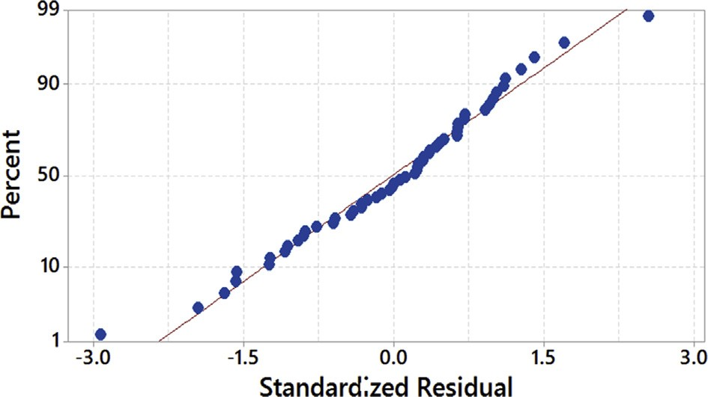

Fig. 21. Normal probability plot of residuals.

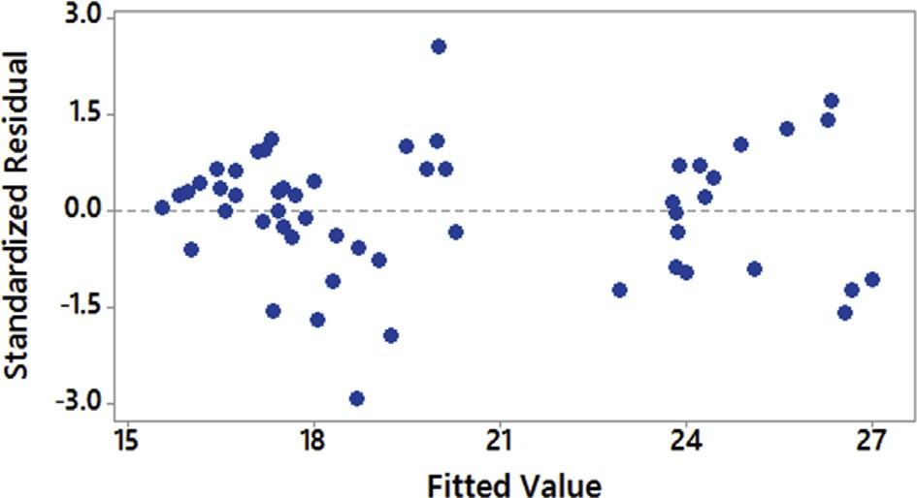

Fig. 22. Residuals versus ﬁtted values.

and 0.0027 respectively. Final values of MLPNN training record are shown in Table 13.

## *Comparison of RSM, MLPNN-GA and ANOVA predictive* models

Table 11 and Fig. 24 shows the comparison of experimentally measured torque force and values predicted by RSM, MLPNN, and MLPNN-GA respectively. It was observed that MLPNN-GA model exhibited lower variations than the MLPNN model. From Fig. 24, observed that RSM and MLPNN-GA predicted values were closely related to experimentally measured torque force. Furthermore, from Table 11 conﬁrmed that an average error of 2.95% with MLPNN was observed before optimization of initial weights and bias. When weights and biases were opti- mized using MLPNN-GA model, the average error was reduced to 1.60% and the number of times required training the MLPNN-GA also signiﬁcantly reduced. The study results indicated that both RSM and MLPNN-GA models achieved an average error less than 4%, and both the models could be used for predicting the torque while drilling of AFRP composites. From Fig. 23 it can be conﬁrmed that MLPNN-GA model has excellent performance and computation time taken by MLPNN-GA is 25 times more than that of RSM.

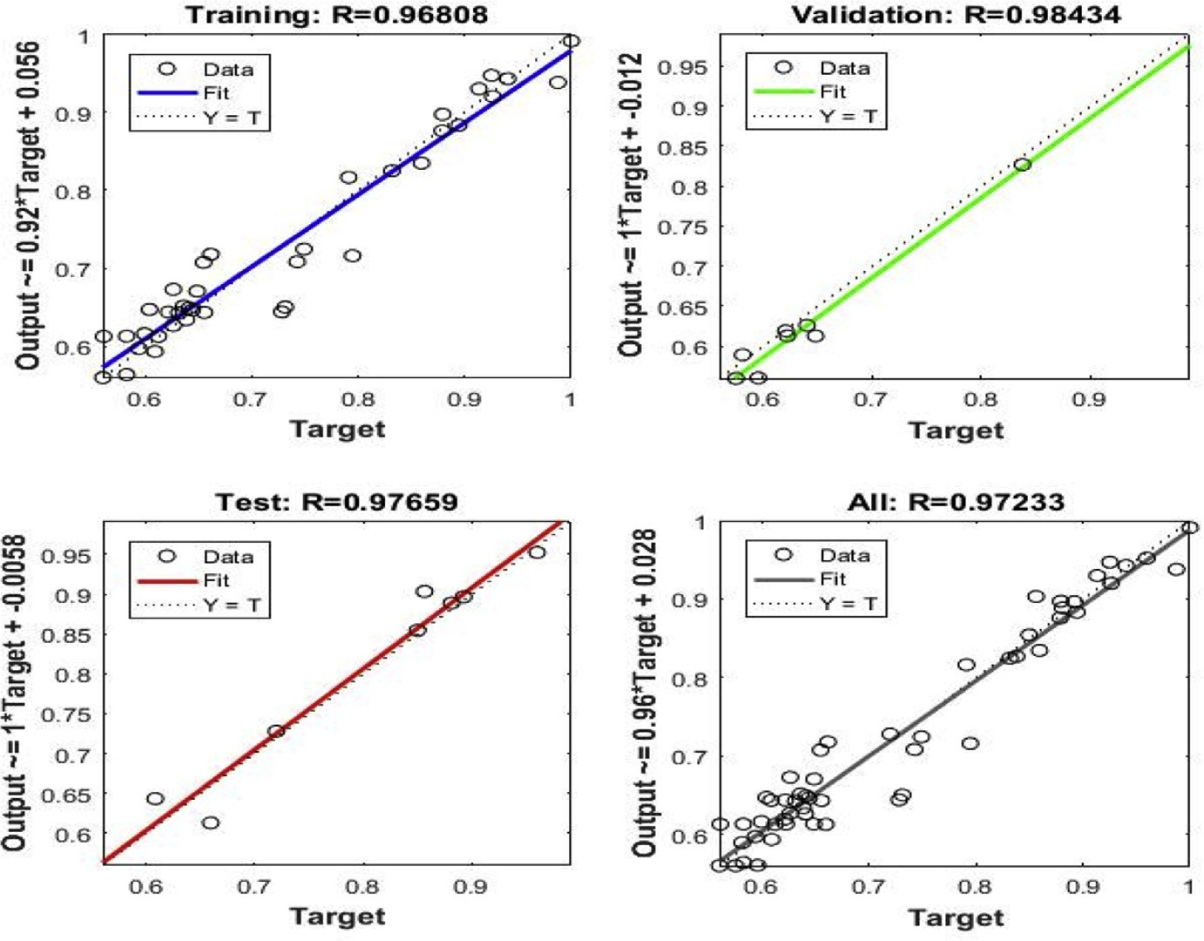

Fig. 23. Linear regressions of predictions and targets of MLPNN-GA.

## *Inﬂuence of process parameters on torque*

Torque in the drilling of AFRP composites had been analyzed through RSM pre- dicted model by generating 3D response surface plots and counterplots. Fig. 25a and b exhibits the eﬀect of drill point angle and drill diameter on torque with speed and feed held constant at 1200 rpm and 50 mm/min respectively. Fig. 26a and b ex- hibits eﬀect of drill point angle and drill diameter on torque with speed and feed held constant at 600 rpm and 100 mm/min respectively. From Figs. 25a and 26a, perceived that drill point angle and drill diameter were sensitive to torque force and linear to the given speed and feed. From the study, it was conﬁrmed that torque is much lesser at drill diameter of 7 mm. Figs. 25b and 26b conﬁrmed that the induced torque was lower at higher speed and lower feed. This indicated that irre- spective of drill point angle and drill diameter, higher speed and lower feed is neces- sary to obtain lower torque. Fig. 27a and b emphasized the eﬀect of SPEED and FEED on torque with drill point angle and drill diameter held constant at 90○ and 10 mm respectively. Similarly, Fig. 28a and b highlighted the eﬀect of SPEED and FEED on torque with drill point angle and feed held constant at 118○ and 7 mm respectively. From Figs. 27a and 28a, conﬁrmed that speed and feed vary non-linearly with drill point angle and drill diameter. Also, from Figs. 27b and 28b observed that maintaining a higher drill point angle and lower drill diameter re- sulted in less torque. Thus, from the study it is conﬁrmed that minimum torque re- sulted from combination of lower values of drill diameter and feed, and higher

Table 13. MLPNN training record for torque force.

Parameter Value

trainFcn ‘traingdx’

trainParam [1 × 1 nnetParam]

performFcn ‘mse’

performParam [1 × 1 struct]

derivFcn ‘defaultderiv’

divideFcn ‘dividerand’

divideMode ‘sample’

divideParam [1 × 1 struct]

trainInd [1 × 38 double]

valInd [3 6 8 12 27 47 48 50]

testInd [4 15 18 20 30 41 43 51]

stop ‘Maximum epoch reached.’

num_epochs 5000

trainMask {[1 × 54 double]}

valMask {[1 × 54 double]}

testMask {[1 × 54 double]}

best_epoch 96

goal 0

states {‘epoch’ ‘time’ ‘perf’ ‘vperf’ ‘tperf’ ‘gradient’ ‘val_fail’ ‘lr’}

epoch [1 × 5001 double]

time [1 × 5001 double]

perf [1 × 5001 double]

vperf [1 × 5001 double]

tperf [1 × 5001 double]

gradient [1 × 5001 double]

val_fail [1 × 5001 double]

lr [1 × 5001 double]

best_perf 0.3858

best_vperf 1.4342

best_tperf 0.6894

values of speed and drill point angle, which is necessary in the drilling of AFRP composites. As the cutting speed increased there is an increase in temperature due to friction between the board and the cutting edge. This led to softening of the matrix which resulted in less amount of material gets attached to the drill bit and less dete- rioration of the drilling surface. Also, at larger drill point angle, the tool has small lip length which created the less torque. Similarly, the contact area of the hole enlarged with increase in the drill diameter, which resulted rise in the torque. Furthermore, the feed rate is in direct relationship with speciﬁc cutting energy. The area of speciﬁc

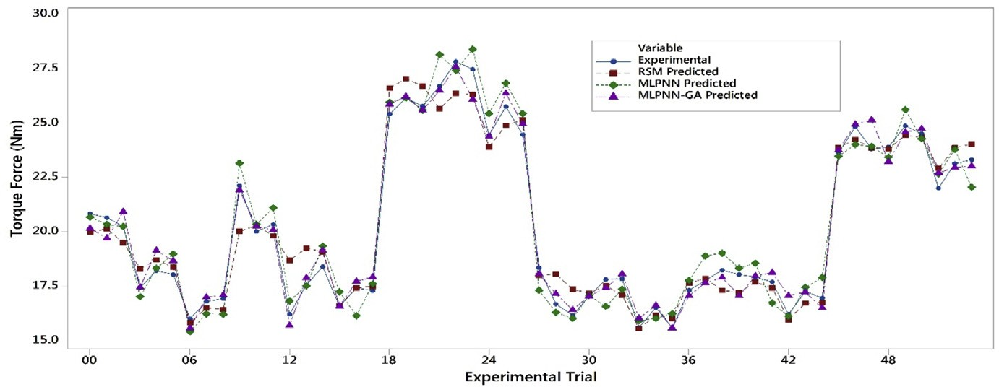

Fig. 24. Comparison plots of experimental and predicted results.

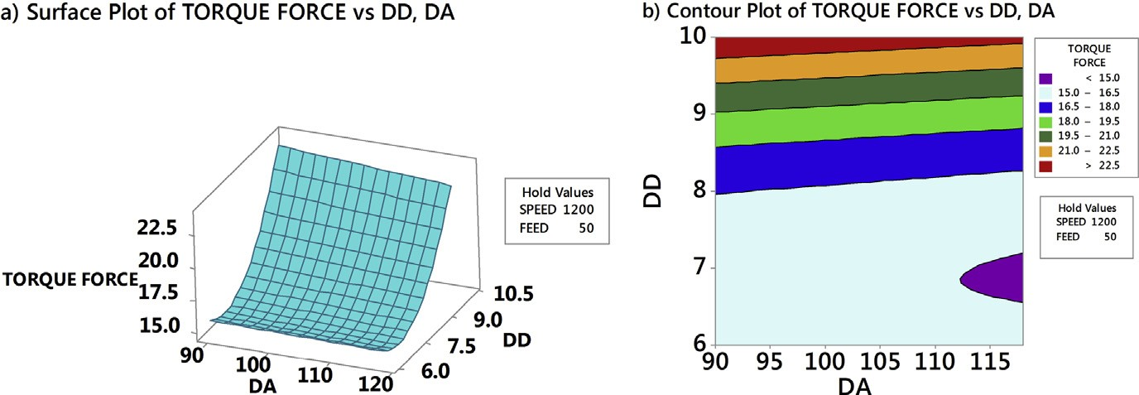

Fig. 25. Eﬀect of drill point angle and drill diameter on torque for a speed ¼ 1200 rpm and feed ¼ 50 mm/min.

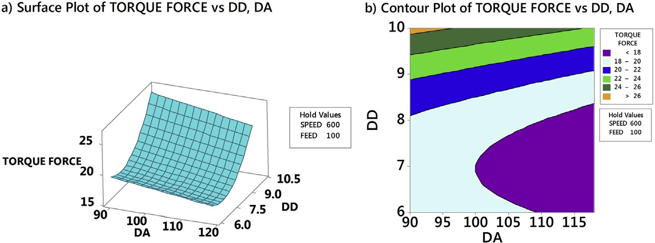

Fig. 26. Eﬀect of drill point angle and drill diameter on torque for a speed ¼ 600 rpm and feed ¼ 100 mm/min.

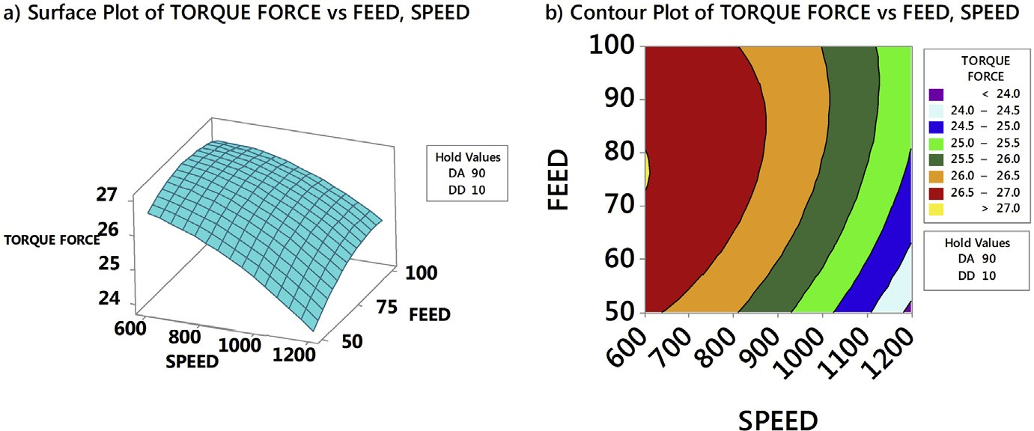

Fig. 27. Eﬀect of speed and feed on torque for a point angle ¼ 90○ and drill diameter ¼ 10 mm.

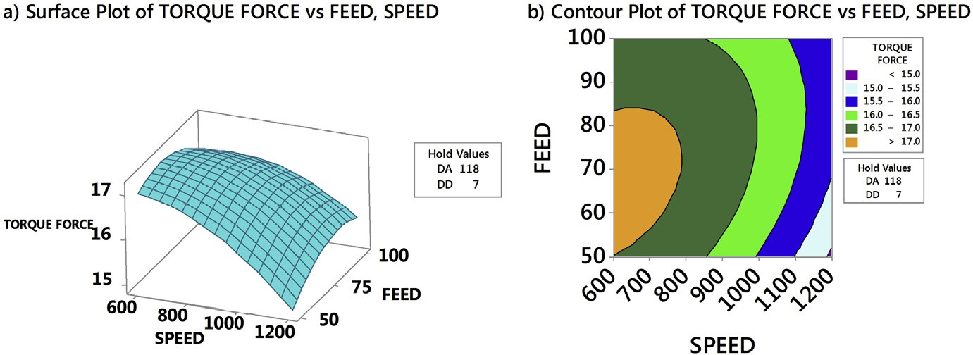

Fig. 28. Eﬀect of speed and feed on torque for a point angle ¼ 118○ and drill diameter ¼ 7 mm.

cutting energy also increased with enhanced feed, which demanded high torque and more damage to AFRP composites.

## *Selection of optimum parameters*

The obtained torque results were transformed into S-N ratio using Equation (10). Table 14 and Fig. 29 represent the response table for S-N ratio and plot of S-N ratio

Table 14. Response table for signal to noise ratios.

Level DA DD SPEED FEED

|  |  |  |  |  |
| --- | --- | --- | --- | --- |
| 1 | —26.26 | —24.87 | —26.35 | —25.82 |
| 2 | —25.62 | —25.05 | —26.04 | —26.05 |
| 3 |  | —27.90 | —25.44 | —25.95 |
| Delta | 0.64 | 3.03 | 0.91 | 0.23 |
| Rank | 3 | 1 | 2 | 4 |

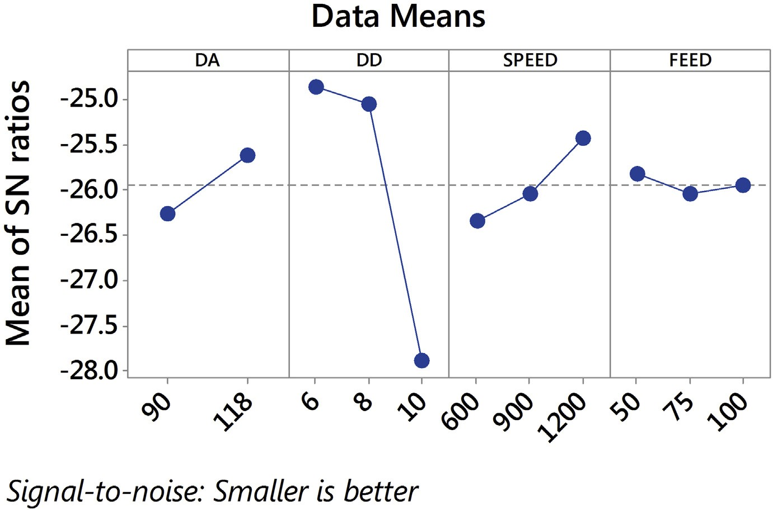

Fig. 29. Torque force: plot of S-N ratio.

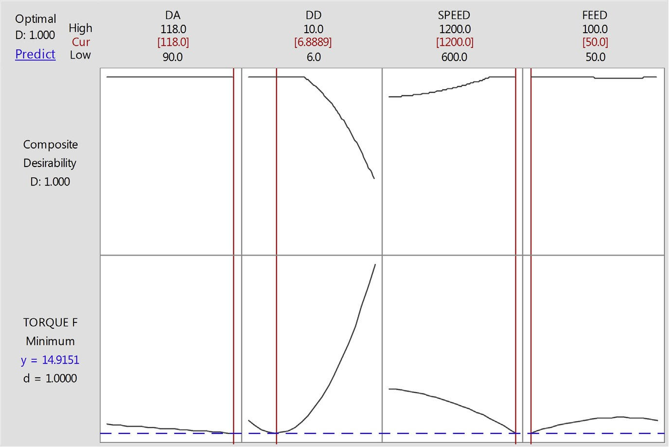

Fig. 30. RSM: optimization plot of torque.

respectively. From the Table 12 delta values and Fig. 29, it is clear that drill diam- eter, drill point angle are the most signiﬁcant factors aﬀecting the torque. These re- sults were in line with surface and counterplots of torque.

## *Optimization of torque force*

RSM and MLPNN-GA were used to optimize the torque force and plots were gener- ated using ’MINITAB0 software. Figs. 30 and 31 plots showed the optimum combi- nations of the factors were required to achieve the minimum torque force. It can be seen that optimal values of torque were close to each other with a deviation of less

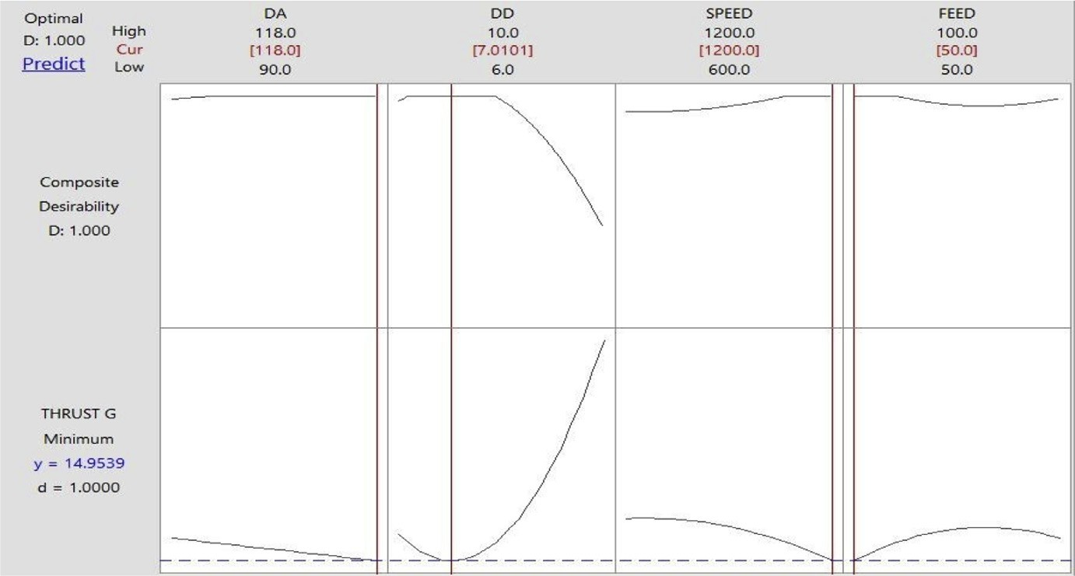

Fig. 31. MLPNN-GA: optimization plot of torque.

than 1%. The study results demarcated that both RSM and MLPNN-GA could be used for modeling of torque force. According to Figs. 30 and 31, DA value of 118○, DD of 7 mm, Speed of 1200 rpm and feed of 50 mm/min are the best combi- nation to obtain the minimum torque.

# Conclusions

An investigative analysis of the inﬂuence of process parameters on thrust force and torque in the drilling of Aramid Fibre Reinforced Plastic (AFRP) composites had been carried out in this paper and the following are the outcomes of the work:

1.

|  |  |  |
| --- | --- | --- |
| The thrust force and torque were studied with respect to cutting speed, feed rate, | | |
| drill point angle and drill diameter by developing RSM and MLPNN-GA | | |
| models. The developed MLPNN-GA model provided higher accuracy than | | |
| RSM. The predicted values of thrust force and torque of RSM and MLPNN- | | |
| GA models closely matched with the experimental values which signiﬁed the | | |
| accuracy of the developed model. | |  |
| The values of optimum thrust force and torque were obtained by response opti- | | |
| mizer of RSM and MLPNN-GA. |  | |

2.

They were close to each other with a deviation of less than 1% error. This showed that MLPNN-GA model could be used eﬀec- tively to predict drilling parameters in AFRP composites.

3.

The study indicated that parameters required to obtain the minimum thrust force

are 90○drill point angle, 6 mm drill diameter, 1200 rpm spindle speed and 50

mm/min feed rate. Similarly, parameters to obtain the minimum torque force

7 mm drill diameter, 1200 rpm spindle speed

and 50 mm/min feed rate.

1. This study recommends the use of high speed and low feed combination and drill point angles of 90○e118○ to reduce the delamination of the materials in the drilling of AFRP composites. Also, normal probability plots of the residuals follow a straight-line pattern indicating that this work would be useful for indus- tries during the selection of process parameters for drilling of AFRP composites.

are 118○ drill point angle, 6.9

w

# Declarations

Author contribution statement

Anarghya A., Harshith D.N., Nitish Rao: Analyzed and interpreted the data; Contrib- uted reagents, materials, analysis tools or data; Wrote the paper.

Nagaraj S. Nayak: Conceived and designed the experiments; Analyzed and inter- preted the data; Contributed reagents, materials, analysis tools or data.

Gurumurthy B.M., Abhishek V.N., Ishwar Gouda S. Patil: Performed the experi- ments; Analyzed and interpreted the data; Contributed reagents, materials, analysis tools or data; Wrote the paper.

# Funding statement

This research did not receive any speciﬁc grant from funding agencies in the public, commercial, or not-for-proﬁt sectors.

# Competing interest statement

The authors declare no conﬂict of interest.

# Additional information

No additional information is available for this paper.

# References

* 1. [C. Soutis, Fibre reinforced composites in aircraft construction, Prog. Aerosp. Sci. 41 (2005) 143](http://refhub.elsevier.com/S2405-8440(17)31277-X/sref1)e[151](http://refhub.elsevier.com/S2405-8440(17)31277-X/sref1).
  2. [T.J. Singh, S. Samanta, Characterization of Kevlar](http://refhub.elsevier.com/S2405-8440(17)31277-X/sref2) ﬁ[bre and its composites: a review, Mater. Today Proc. 2 (2015) 1381](http://refhub.elsevier.com/S2405-8440(17)31277-X/sref2)e[1387](http://refhub.elsevier.com/S2405-8440(17)31277-X/sref2).

[3] [J.K. Fink, 13 Aramids, 2014, pp. 301](http://refhub.elsevier.com/S2405-8440(17)31277-X/sref3)e[320](http://refhub.elsevier.com/S2405-8440(17)31277-X/sref3).

1. [G.R. Bishop, N.N.Z. Gindy, An investigation into the drilling of ballistic Kev- lar composites, Compos. Manuf. 1 (1990) 155](http://refhub.elsevier.com/S2405-8440(17)31277-X/sref4)e[159](http://refhub.elsevier.com/S2405-8440(17)31277-X/sref4).
2. [L. Zheng, H. Zhou, C. Gao, J. Yuan, Hole drilling in ceramics/Kevlar ﬁbre reinforced plastics double-plate composite armor using diamond core drill, Mater. Des. 40 (2012) 461](http://refhub.elsevier.com/S2405-8440(17)31277-X/sref5)e[466](http://refhub.elsevier.com/S2405-8440(17)31277-X/sref5).
3. [A. Di Ilio, V. Tagliaferri, F. Veniali, Cutting mechanisms in drilling of aramid composites, Int. J. Mach. Tools Manuf. 31 (1991) 155](http://refhub.elsevier.com/S2405-8440(17)31277-X/sref6)e[165](http://refhub.elsevier.com/S2405-8440(17)31277-X/sref6).
4. [D. Bhattacharyya, D.P.W. Horrigan, A study of hole drilling, Compos. Sci. Technol. 58 (1998) 267](http://refhub.elsevier.com/S2405-8440(17)31277-X/sref7)e[283](http://refhub.elsevier.com/S2405-8440(17)31277-X/sref7).
5. [T. Hirogaki, E. Aoyama, H. Inoue, K. Ogawa, S. Maeda, T. Katayama, Laser drilling of blind via holes in aramid and glass/epoxy composites for multi- layer printed wiring boards, Compos. Part A Appl. Sci. Manuf. 32 (2001) 963](http://refhub.elsevier.com/S2405-8440(17)31277-X/sref8)e[968](http://refhub.elsevier.com/S2405-8440(17)31277-X/sref8).
6. [D. Liu, Y. Tang, W.L. Cong, A review of mechanical drilling for composite laminates, Compos. Struct. 94 (2012) 1265](http://refhub.elsevier.com/S2405-8440(17)31277-X/sref9)e[1279](http://refhub.elsevier.com/S2405-8440(17)31277-X/sref9).
7. [N. Feito, J. Diaz-](http://refhub.elsevier.com/S2405-8440(17)31277-X/sref10)A´[lvarez, J. L´opez-Puente, M.H. Miguelez, Numerical anal-](http://refhub.elsevier.com/S2405-8440(17)31277-X/sref10) [ysis of the inﬂuence of tool wear and special cutting geometry when drilling woven CFRPs, Compos. Struct. 138 (2016) 285](http://refhub.elsevier.com/S2405-8440(17)31277-X/sref10)e[294](http://refhub.elsevier.com/S2405-8440(17)31277-X/sref10).
8. [Y. Karpat, B. Deger, O. Bahtiyar, Drilling thick fabric woven CFRP laminates with double point angle drills, J. Mater. Process. Technol. 212 (2012) 2117](http://refhub.elsevier.com/S2405-8440(17)31277-X/sref11)e[2127](http://refhub.elsevier.com/S2405-8440(17)31277-X/sref11).
9. [K. Palanikumar, Experimental investigation and optimisation in drilling of GFRP composites, Meas. J. Int. Meas. Confed. 44 (2011) 2138](http://refhub.elsevier.com/S2405-8440(17)31277-X/sref12)e[2148](http://refhub.elsevier.com/S2405-8440(17)31277-X/sref12).
10. [T. sunny, J. Babu, J. Philip, Experimental studies on eﬀect of process param- eters on delamination in drilling GFRP composites using Taguchi method, Proc. Mater. Sci. 6 (2014) 1131](http://refhub.elsevier.com/S2405-8440(17)31277-X/sref13)e[1142](http://refhub.elsevier.com/S2405-8440(17)31277-X/sref13).
11. [V. Krishnaraj, A. Prabukarthi, A. Ramanathan, N. Elanghovan, M.S. Kumar,](http://refhub.elsevier.com/S2405-8440(17)31277-X/sref14)

[R. Zitoune, J.P. Davim, Composites: part B optimization of machining param- eters at high speed drilling of carbon](http://refhub.elsevier.com/S2405-8440(17)31277-X/sref14) ﬁ[bre reinforced plastic (CFRP) laminates, Compos. Part B 43 (2012) 1791](http://refhub.elsevier.com/S2405-8440(17)31277-X/sref14)e[1799](http://refhub.elsevier.com/S2405-8440(17)31277-X/sref14).

1. [N.S. Mohan, A. Ramachandra, S.M. Kulkarni, In](http://refhub.elsevier.com/S2405-8440(17)31277-X/sref15)ﬂ[uence of process parameters on cutting force and torque during drilling of glass-ﬁbre polyester reinforced composites, Compos. Struct. 71 (2005) 407](http://refhub.elsevier.com/S2405-8440(17)31277-X/sref15)e[413](http://refhub.elsevier.com/S2405-8440(17)31277-X/sref15).
2. [C.C. Tsao, H. Hocheng, Taguchi analysis of delamination associated with various drill bits in drilling of composite material, Int. J. Mach. Tools Manuf. 44 (2004) 1085](http://refhub.elsevier.com/S2405-8440(17)31277-X/sref16)e[1090](http://refhub.elsevier.com/S2405-8440(17)31277-X/sref16).
3. [C.C. Tsao, Y.C. Chiu, Evaluation of drilling parameters on thrust force in dril- ling carbon ﬁbre reinforced plastic (CFRP) composite laminates using com- pound core-special drills, Int. J. Mach. Tools Manuf. 51 (2011) 740](http://refhub.elsevier.com/S2405-8440(17)31277-X/sref17)e[744](http://refhub.elsevier.com/S2405-8440(17)31277-X/sref17).
4. [U.A. Khashaba, A.I. Selmy, A.A. Megahed, Composites: part A machinability analysis in drilling woven GFR/epoxy composites: part I](http://refhub.elsevier.com/S2405-8440(17)31277-X/sref18) e [eﬀect of machining parameters, Compos. Part A Appl. Sci. Manuf. 41 (2010) 391](http://refhub.elsevier.com/S2405-8440(17)31277-X/sref18)e[400](http://refhub.elsevier.com/S2405-8440(17)31277-X/sref18).
5. [T.V. Rajamurugan, K. Shanmugam, K. Palanikumar, Analysis of delamination in drilling glass](http://refhub.elsevier.com/S2405-8440(17)31277-X/sref19) ﬁ[bre reinforced polyester composites, Mater. Des. 45 (2013) 80](http://refhub.elsevier.com/S2405-8440(17)31277-X/sref19)e[87](http://refhub.elsevier.com/S2405-8440(17)31277-X/sref19).
6. [N. Zarif, H. Heidary, G. Minak, M. Ahmadi, E](http://refhub.elsevier.com/S2405-8440(17)31277-X/sref20)ﬀ[ect of the drilling process on the compression behavior of glass/epoxy laminates, Compos. Struct. 98 (2013) 59](http://refhub.elsevier.com/S2405-8440(17)31277-X/sref20)e[68](http://refhub.elsevier.com/S2405-8440(17)31277-X/sref20).
7. [E. Kilickap, Optimization of cutting parameters on delamination based on Ta- guchi method during drilling of GFRP composite, Expert Syst. Appl. 37 (2010) 6116](http://refhub.elsevier.com/S2405-8440(17)31277-X/sref21)e[6122](http://refhub.elsevier.com/S2405-8440(17)31277-X/sref21).
8. [S.R. Karnik, V.N. Gaitonde, J.C. Rubio, A.E. Correia, A.M. Abr~ao,](http://refhub.elsevier.com/S2405-8440(17)31277-X/sref22)

[J.P. Davim, Delamination analysis in high speed drilling of carbon ﬁbre rein- forced plastics (CFRP) using artiﬁcial neural network model, Mater. Des. 29 (2008) 1768](http://refhub.elsevier.com/S2405-8440(17)31277-X/sref22)e[1776](http://refhub.elsevier.com/S2405-8440(17)31277-X/sref22).

1. [V. Kumar, V. Ganta, Optimization of process parameters in drilling of GFRP composite using Taguchi method, Integr. Med. Res. 3 (2013) 35](http://refhub.elsevier.com/S2405-8440(17)31277-X/sref23)e[41](http://refhub.elsevier.com/S2405-8440(17)31277-X/sref23).
2. [V.N. Gaitonde, S.R. Karnik, J.C. Rubio, A.E. Correia, A.M. Abr~ao,](http://refhub.elsevier.com/S2405-8440(17)31277-X/sref24)

[J.P. Davim, Analysis of parametric inﬂuence on delamination in high-speed drilling of carbon ﬁbre reinforced plastic composites, J. Mater. Process. Tech- nol. 203 (2008) 431](http://refhub.elsevier.com/S2405-8440(17)31277-X/sref24)e[438](http://refhub.elsevier.com/S2405-8440(17)31277-X/sref24).

1. [X. Wang, P.Y. Kwon, C. Sturtevant, D.D.W. Kim, J. Lantrip, Tool wear of coated drills in drilling CFRP, J. Manuf. Process. 15 (2013) 87](http://refhub.elsevier.com/S2405-8440(17)31277-X/sref25)e[95](http://refhub.elsevier.com/S2405-8440(17)31277-X/sref25).
2. [C.C. Tsao, H. Hocheng, Y.C. Chen, Delamination reduction in drilling com- posite materials by active backup force, CIRP Ann. Manuf. Technol. 61 (2012) 91](http://refhub.elsevier.com/S2405-8440(17)31277-X/sref26)e[94](http://refhub.elsevier.com/S2405-8440(17)31277-X/sref26).
3. [N. Zarif Karimi, H. Heidary, G. Minak, Critical thrust and feed prediction models in drilling of composite laminates, Compos. Struct. 148 (2016) 19](http://refhub.elsevier.com/S2405-8440(17)31277-X/sref27)e[26](http://refhub.elsevier.com/S2405-8440(17)31277-X/sref27).
4. [P. Rahme, Y. Landon, F. Lachaud, R. Piquet, P. Lagarrigue, Delamination- free drilling of thick composite materials, Compos. Part A Appl. Sci. Manuf. 72 (2015) 148](http://refhub.elsevier.com/S2405-8440(17)31277-X/sref28)e[159](http://refhub.elsevier.com/S2405-8440(17)31277-X/sref28).
5. [N. Feito, J. L´opez-puente, C. Santiuste, M.H. Migu´elez, Numerical prediction](http://refhub.elsevier.com/S2405-8440(17)31277-X/sref29) [of delamination in CFRP drilling, Compos. Struct. 108 (2014) 677](http://refhub.elsevier.com/S2405-8440(17)31277-X/sref29)e[683](http://refhub.elsevier.com/S2405-8440(17)31277-X/sref29).
6. [C.C. Tsao, Experimental study of drilling composite materials with step-core drill, Mater. Des. 29 (2008) 1740](http://refhub.elsevier.com/S2405-8440(17)31277-X/sref30)e[1744](http://refhub.elsevier.com/S2405-8440(17)31277-X/sref30).
7. [A.K. Jain, J. Mao, K.M. Mohiuddin, Artiﬁcial neural networks: a tutorial, Comput. Long Beach Calif. 29 (1996) 31](http://refhub.elsevier.com/S2405-8440(17)31277-X/sref31)e[44](http://refhub.elsevier.com/S2405-8440(17)31277-X/sref31).
8. [M. a Shahin, M.B. Jaksa, H.R. Maier, Artiﬁcial neural network applications in geotechnical engineering, Aust. Geomech. 36 (2001) 49](http://refhub.elsevier.com/S2405-8440(17)31277-X/sref32)e[62](http://refhub.elsevier.com/S2405-8440(17)31277-X/sref32).
9. [S. Haykin, N. Networks, A.C. Foundation, Exploring the diversity of artiﬁcial neural network architectures, J. Math. Psychol. 292 (1997) 287](http://refhub.elsevier.com/S2405-8440(17)31277-X/sref33)e[292](http://refhub.elsevier.com/S2405-8440(17)31277-X/sref33).
10. B. Yegnanarayana, Artiﬁcial Neural Networks, Prentice-Hall of India, 1999. [https:// books.google.co.in/books/about/ARTIFICIAL_NEURAL_NETWORKS.html? id](https://books.google.co.in/books/about/ARTIFICIAL_NEURAL_NETWORKS.html?id=RTtvUVU_xL4C)¼[RTtvUVU_xL4C](https://books.google.co.in/books/about/ARTIFICIAL_NEURAL_NETWORKS.html?id=RTtvUVU_xL4C). (Accessed 18 September 2017).
11. [D.B. Fogel, Review of computational intelligence: imitating life [Book re- views], Proc. IEEE 83 (1995) 1588](http://refhub.elsevier.com/S2405-8440(17)31277-X/sref35)e[1592](http://refhub.elsevier.com/S2405-8440(17)31277-X/sref35).
12. [G. Dini, Online prediction of delamination in drilling of GFRP by using a neu- ral network approach, Mach. Sci. Technol. (2007)](http://refhub.elsevier.com/S2405-8440(17)31277-X/sref36).
13. [E.U. Enemuoh, A.S. El-gizawy, A.C. Okafor, An approach for development of damage-free drilling of carbon ﬁbre reinforced thermosets, Int. J. Mach. Tools Manuf. 41 (2001) 1795](http://refhub.elsevier.com/S2405-8440(17)31277-X/sref37)e[1814](http://refhub.elsevier.com/S2405-8440(17)31277-X/sref37).
14. [F. Yan, Z. Lin, New strategy for anchorage reliability assessment of GFRP bars to concrete using hybrid artiﬁcial neural network with genetic algorithm, Compos. Part B 92 (2016) 420](http://refhub.elsevier.com/S2405-8440(17)31277-X/sref38)e[433](http://refhub.elsevier.com/S2405-8440(17)31277-X/sref38).
15. [R.R.M. Saravanana, D. Ramalingamb, G. Manikandanc, Multi objective opti- mization of drilling parameters using genetic algorithm, Proc. Eng. 38 (2012) 197](http://refhub.elsevier.com/S2405-8440(17)31277-X/sref39)e[207](http://refhub.elsevier.com/S2405-8440(17)31277-X/sref39).
16. [V. Krishnaraj, A. Prabukarthi, A. Ramanathan, N. Elanghovan, M.S. Kumar,](http://refhub.elsevier.com/S2405-8440(17)31277-X/sref40)

[R. Zitoune, J.P. Davim, Optimization of machining parameters at high speed drilling of carbon](http://refhub.elsevier.com/S2405-8440(17)31277-X/sref40) ﬁ[bre reinforced plastic (CFRP) laminates, Compos. Part B Eng. 43 (2012) 1791](http://refhub.elsevier.com/S2405-8440(17)31277-X/sref40)e[1799](http://refhub.elsevier.com/S2405-8440(17)31277-X/sref40).